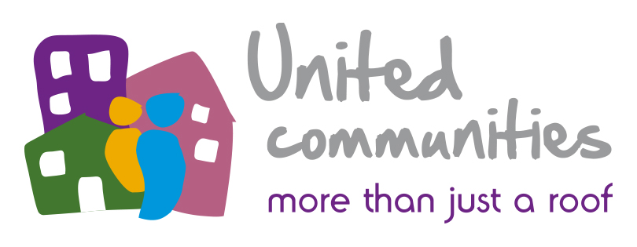

UNITED COMMUNITIES BOARD MEMBER APPLICATION FORM

PRIVATE & CONFIDENTIAL

How did you learn about this position?………………………………………………………………

PERSONAL INFORMATION
Last Name:
First Name:
Title: Mr/Mrs/Miss/Ms/Other
Address (inc Postcode):
Contact Numbers: | Daytime: Evening:
 | Email:

COMMUNITY/VOLUNTARY EXPERIENCE

Please provide details of any community/voluntary experience and any other Board or voluntary Committee Membership. Please include any positions held and any membership of other housing association boards.
PROFESSIONAL QUALIFICATIONS/RELEVANT EDUCATION
Please provide details of membership of professional bodies, or relevant education, in particular financial qualifications and commercial expertise

PRESENT EMPLOYMENT (If applicable)
Job Title:
Employer/Organisation Name:
Location:
Nature of Business:
Relevant Work / Professional Experience: (Please attach a CV if you feel this is relevant)

ADDITIONAL RELEVANT INFORMATION
Please indicate how your experience/interest/skills fulfill the Board member person specification (please continue on a separate sheet if necessary). Please tell us why you want to be a Board Member of United Communities.

Are you known or related to any staff member or Board Member of United Communities?
If yes, please give details.

Are you aware of any potential conflicts of interest which would affect your role as a Board member?
If yes, please give details.

Have you ever been declared bankrupt or entered into an individual voluntary agreement? (IVA).

Yes No (If yes, please explain)

REHABILITATION OF OFFENDERS ACT 1974
Please give details below of any convictions or charges outstanding of all offences (or alleged offences). If you inadvertently disclose a conviction, which is regarded as “spent”, it will be ignored (do not include parking offences)

DATA PROTECTION ACT 1998
This information or data which you have supplied on this form will be processed and held on computer and will be used for recruitment and selection purposes only.

I confirm that, to the best of my knowledge, the information contained on this form is accurate.
Signature: | Date:

Please return this application to:
Sarah Moon, Corporate Services Officer,, United Communities
Eden House , Eastgate Business Park, Bristol BS5 6XX or email to joinus@unitedcommunities.org.uk

