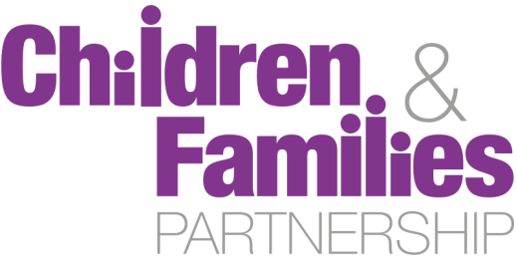

Joint Health Outcomes Group

Terms of Reference
Version: 2.0

Date: 31th August 2016

Contact: Bonnie Curran (0117 35 74474) or Jo Williams (0117 9223355)

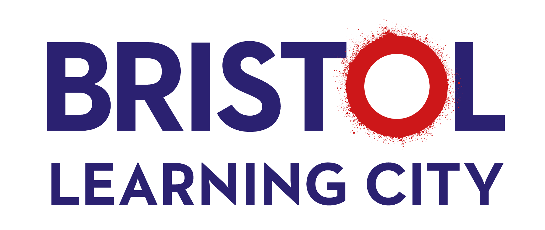
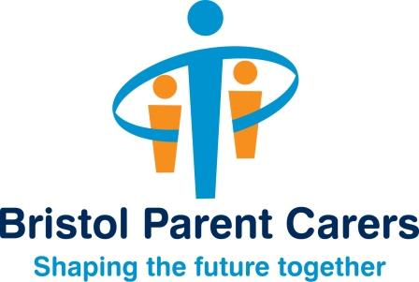
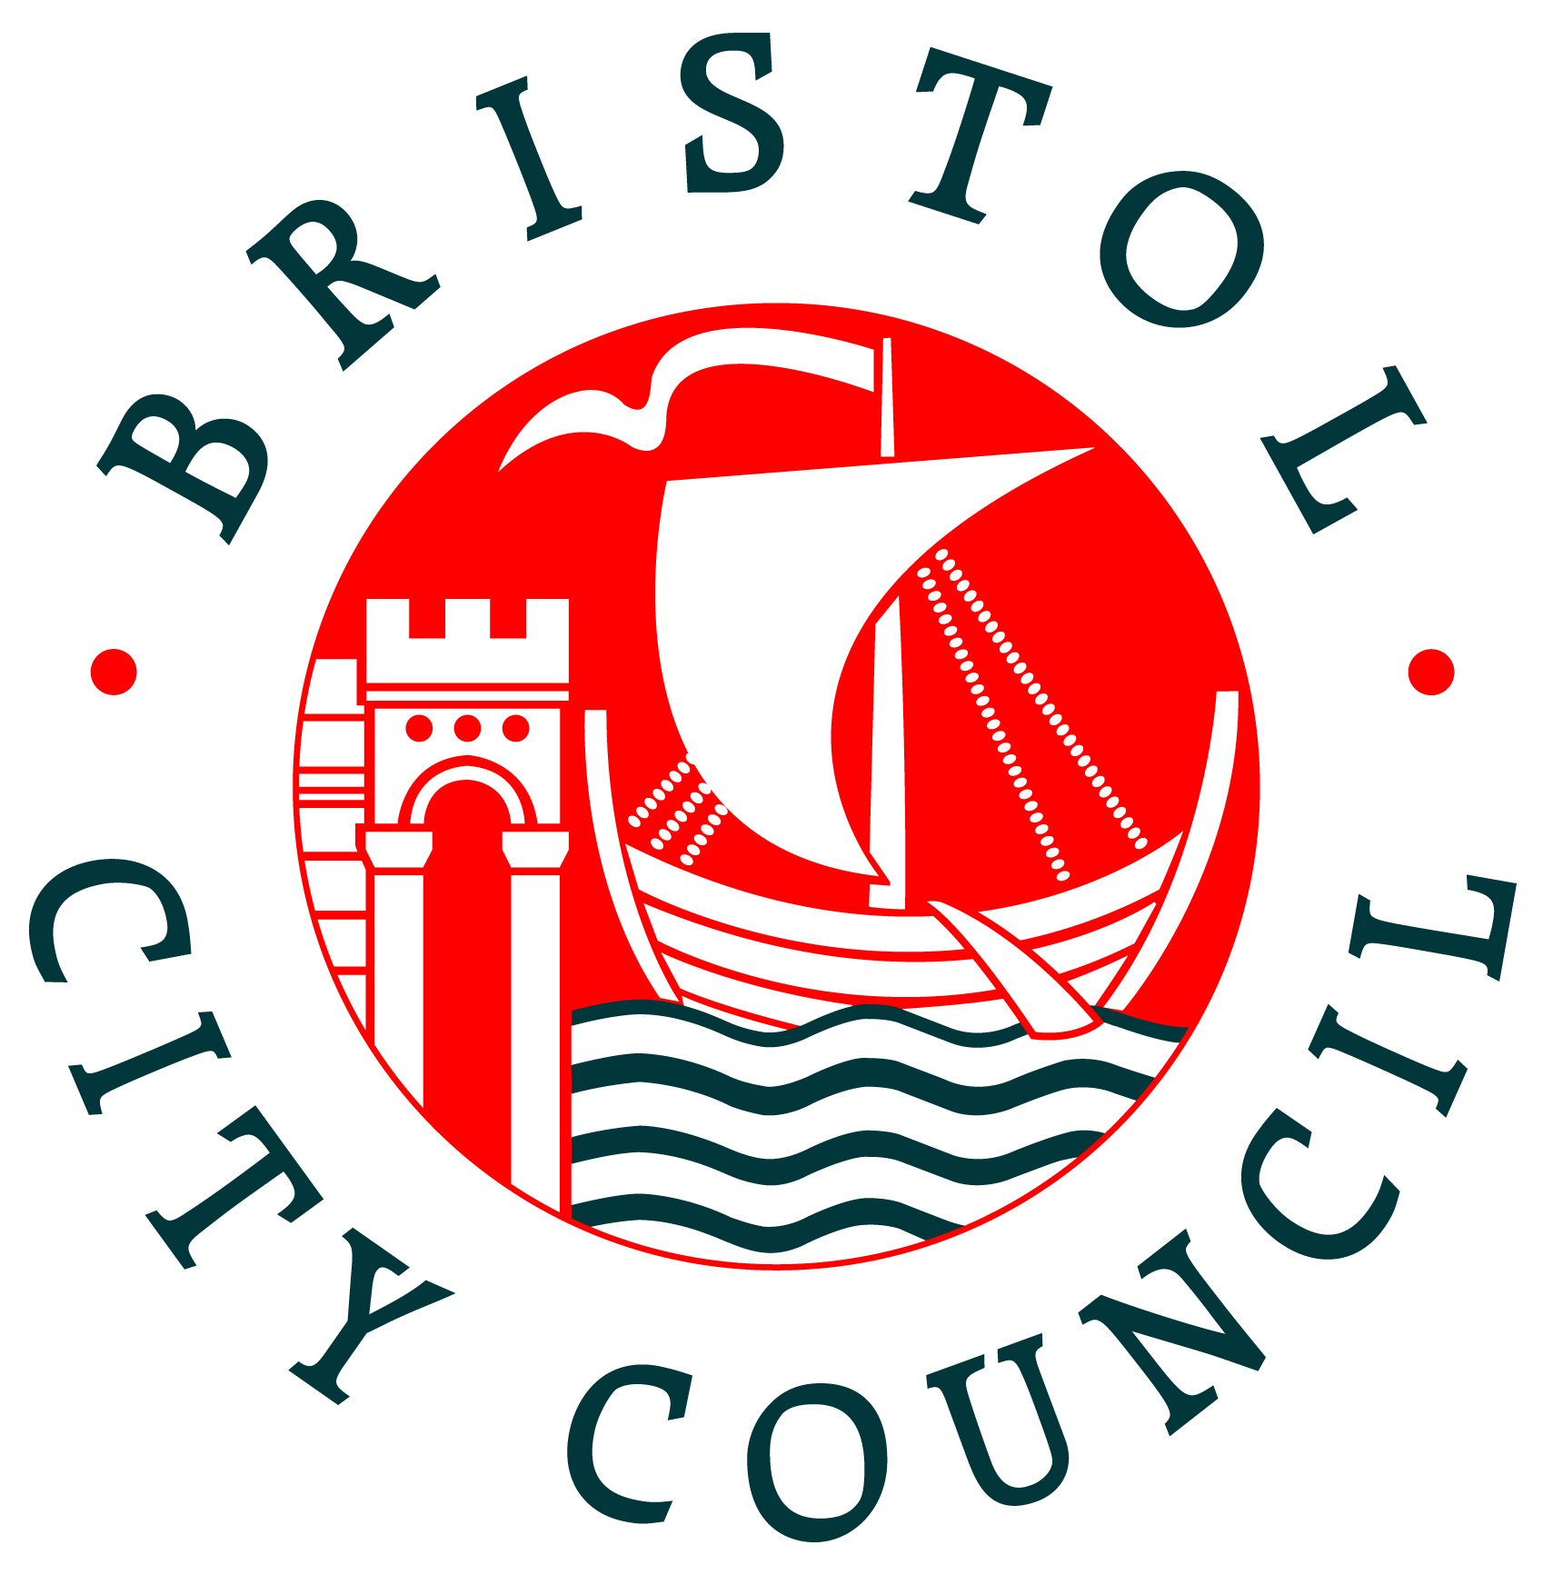

- Purpose

The Bristol Joint Health Outcomes (JHO) Group is a sub-group of the Bristol Children and Families Partnership Board focused on ensuring an integrated approach to promoting and maintaining positive physical and emotional health and wellbeing of children, young people and families in Bristol.

- Aims and Scope

  - Priorities
The work of the JHO group will focus on joint work across agencies to deliver the priorities set out in the Bristol Strategy for Children, Young People and Families, and elements of the Health and Wellbeing Strategy as they relate to children and young people.

The key identified health priorities are:
- Emotional health
- Maternal health and early years
- Healthy weight (joint with Health and Wellbeing Board)

A cross-cutting theme will be addressing Child Poverty and Inequality, which will include promoting health in vulnerable groups, in particular Looked After Children and Care Leavers.

The group will be flexible to address emerging issues and support the improvement of other health outcomes which need a multiagency approach, e.g. oral health.

  - Functions of the subgroup
The work of the subgroup will span a number of functions, including:
- Needs assessment: providing comments about child specific JSNA chapters that are relevant to the partnership and ensuring findings are taking into account in commissioning and service delivery. Each JSNA chapter will have a group that works on the development of that specific chapter, a function the subgroup could fulfil where another group does not exist. Formal sign-off of chapters is by the JSNA steering group.
- Strategy: comment on the development or review of strategies where there needs to be a multiagency approach.
- Commissioning and service development: to ensure alignment of resources and of decision making processes.
- Evaluation: to support the evaluation of service development
- Outcome monitoring including through contributing indicators to the Board indicator set.

The group will take on a range of roles, depending on the piece of work, including:
- Assurance though comment and feedback on behalf of the Board.
- Providing comment on papers prior to Board presentation.
- Set up task and finish groups to develop specific pieces of work.

The subgroup will develop a work plan to address the key priorities with 3-4 key outcomes to deliver in the next 2 years.

- Working principles

To achieve these aims, members of the Group undertake to:
- Support the principles of prevention and early intervention
- Prioritise reducing health inequalities, and improving outcomes for vulnerable children, young people and families
- Take an evidence-based approach to understanding need, and to the planning, design, commissioning and delivery of our services to ensure that children and young people’s and families’ needs are met.
- Listen to the voices of children, young people and carers, co-produce wherever possible and be open and honest in our response to them.
- Ensure safeguarding of children and young people is taken into account in all areas of work.
- Take account of statutory guidance in developing local arrangements

- Governance and accountability

  - The subgroup will report directly to the Children and Families Partnership Board, and provide a highlight report for each Board meeting, or as requested.

  - The Group will make recommendations to the organisations represented at it, including the Council (e.g. leadership teams, scrutiny, cabinet), the Bristol Clinical Commissioning Group and other participating bodies. The group may make recommendations to other partnership Boards, e.g. the Health and Wellbeing Board and Bristol Safeguarding Children Board where appropriate.

  - Members of the Group remain wholly accountable to their employing organisations, and thus should be sufficiently empowered to discuss and influence the strategic direction of that organisation in a partnership context.

  - The relationship of the JHO subgroup to other strategic and partnership groups addressing the health needs of children and young people is outlined in Figure 1 below.

- Meeting arrangements

  - The Group is chaired by the Consultant in Public Health: Children and Young People, with the Director of Public Health providing a link between this subgroup and the Board.

  - The Group will meet six times per year, on alternate months to the Board. The Chair may call additional meetings of the Group and shall do so if he or she receives a request from two or more members of the Group.

  - The quorum for a meeting of the Group shall be 50% of the representatives set out in the membership, which must include at least one representative of Bristol City Council and the Clinical Commissioning Group.

- Membership

Joint Health Outcomes Group
Members
Consultant in Public Health: Children and Young People (chair) | Jo Williams | Bristol City Council
Director of Public Health and link CFPB Board member | Becky Pollard | Bristol City Council
Consultant in Public Health | Jo Copping | Bristol City Council
Programme Manager Children and Maternity Commissioning | Inge Shepherd | Bristol CCG
Strategic Commissioning Manager | Rebecca Cross | Bristol City Council / NHS Bristol CCG
Commissioning Manager - Children | Hannah Russell | Bristol City Council
Programme Manager Public Health: Children and Young People | Anne Colquhoun | Bristol City Council
Planning & Development Advisor, Strategic Planning Team | Bonnie Curran | Bristol City Council
Service Manager Early Years | Sally Jaeckle | Bristol City Council
VCS Rep | tbc | tbc
Schools (Early yrs, Primary, Secondary, Special) | tbc | tbc

  - Membership is primarily granted to those with senior strategy and commissioning responsibility and resource management oversight in partner organisations. Members must declare any conflict of interest arising in meetings. This includes, but is not limited to, any provider functions they perform which may fall within the scope of strategic commissioning and decision-making by the Group.

  - In addition to the members identified above, additional members will be asked to attend for specific agenda items or to update on the progress of specific actions.

- Roles and responsibilities of members

  - In undertaking these responsibilities the members of the Group will ensure that it continues to:
- Consult with appropriate forums and groups
- Co-opt members such as practitioners, children and young people, service providers, parents/carers as deemed necessary to provide further advice and information
- Ensure that the participation of children, young people and their families are integral to its work
- Oversee arrangements for effective sharing of information across the partner agencies.

  - A member of the Group who is unable to attend a Group meeting may appoint a substitute to attend in his or her place provided that:
- The substitute is a member or employee of the same organisation as the person for whom they are substituting
- The substitute has been given the same authority to represent and commit (where applicable) the organisation as the person for whom they are substituting
- Any substitution must be a single appointment for the whole of a meeting
- A person may not send a substitute if the Group has directed them to attend.

- Review of Terms of Reference

  - These Terms of Reference will be reviewed at least once every two years, or at times when the Group is otherwise reviewing its constitution or activity.
Figure 1 – relationship of the Joint Health Outcomes subgroup to other strategic and partnership groups
[see separate sheet until finalised, for ease of formatting]

