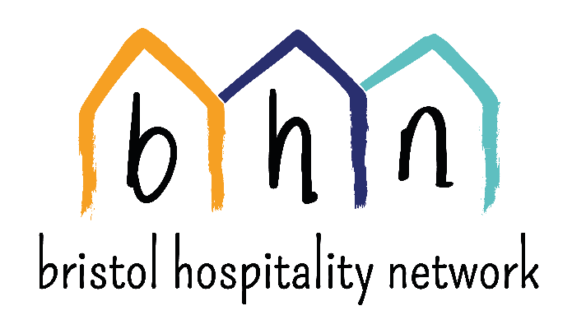

Equal Opportunities Monitoring Form
Bristol Hospitality Network is an equal opportunities employer. We are committed to equalities monitoring to improve its services. This is so that we can address any access issues and barriers that some people may face. We also want to make sure that everybody who accesses our services is equally happy with the outcome.

In order to ensure that we are moving closer towards this aim, all applicants are asked to answer the following questions, in strictest confidence and without giving their name.

You may return this form separately to your application form. However, if you enclose it with your application form, it will be separated from the application form on receipt. It will be used for statistical purposes only and will be destroyed once the statistics have been recorded.

Please be assured that this information is held anonymously and confidentially in accordance with the Data Protection Act 1998.

POST applied for

PLEASE PLACE AN ‘X’ IN THE APPROPRIATE BOX FOR EACH QUESTION

1. Race and Ethnicity
How would you describe your cultural background?

2. Sex (please tick)
Female ☐ Male ☐ Prefer not to answer ☐

3. Gender reassignment (please tick)
Is your gender identity the same as the gender you were originally assigned at birth?
Yes ☐ No ☐ Prefer not to answer ☐

4. Age (please tick)
Under 18 ☐ 18 – 24 ☐ 25 – 49 ☐
50 – 64 ☐ 65 – 74 ☐ 75 or over ☐
Prefer not to answer ☐

5. Sexual Orientation (please tick)
Bisexual ☐ Lesbian or Gay ☐
Heterosexual ☐ Prefer not to answer ☐

6. Disability (please tick)
Do you consider yourself disabled?
Yes ☐ No ☐ Prefer not to answer ☐

7. Religion and Belief: How would you describe your Religion or Belief?

Thank you for taking the time to fill in this form. It helps us to ensure that we plan and provide fair and accessible services. It will be separated from your application and remain anonymous.

