We are recruiting volunteers to support
Conflict Resolution within Bristol Hate Crime & Discrimination Services*
Resolve West is an independent, charitable organisation with over 30 years’ experience of providing a confidential service to people experiencing conflict, crime or discrimination.
(*a partnership between SARI, Brandon Trust, LGBT Bristol, Bristol Mind, Avon & Bristol Law Centre and Resolve West)

We work with people who have experienced hate crime or discrimination to resolve conflict and repair harm.
- As a volunteer you will initially receive training in mediation (6 days attending with some private study) as well as ongoing training and supervision throughout your volunteering role.
- Our volunteer practitioners co-work cases supportively and as a newly-trained volunteer you would be teamed up with an experienced mentor.
- The work is flexible and person-centred so our volunteers work at different times of the day and week, visiting people in their homes or other appropriate venues across Bristol.
We are committed to promoting and maintaining diversity among our volunteer team. Our team welcomes and supports new volunteers; we learn from each other and from clients and their experiences.

Successful Candidates will:
- Be interested and willing to learn a new set of skills
- Be available for a volunteer selection day and initial training dates: (7 days)
- Be willing to commit around 95 hours volunteering time per year for at least two years after the initial training period.
- Be committed to understanding and resolving conflict, including that arising from hate crime and discrimination (please see next page for more detailed specification)
We would particularly welcome BME or LGBT+ and other applicants with characteristics or experiences which might add to the diversity of our volunteer group.

We would like to hear from you if you are interested in this volunteering opportunity and you are available to attend a selection day and the 6 training days.  Please complete the online application form  ( http://bit.ly/rw-ta ) or fill in the form below and return to Resolve West by post or email by 27th January 2020 |  | Selection and Training Dates  Friday 7th February (Selection Day)  Thursday 27th February (9am - 5pm)  Friday 28th February (9am - 5pm)  Thursday 5th March (9am - 5pm)  Friday 6th March (9am - 5pm)  Thursday 12th March (9am - 5pm)  Friday 13th March (9am - 5pm)
Please email or phone Hannah Pepper if you have any questions or require any support with your application. hannah@resolvewest.org  0117 9415379 / 07714 237107 | 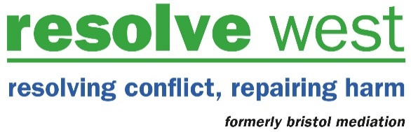

Job description for Conflict Resolution Practitioner.
Overall purpose
To provide a service of conflict resolution to people in dispute living in Bristol and the surrounding areas.

Accountability
To the management committee of RW through the Director.

Key tasks
- To operate at all times within RW’s Good Practice Guidelines, equal opportunities policy and ethical policy framework
- Visit clients in their homes, listen to them and help them decide on the most appropriate course of action
- Work with both parties in a dispute, help them to communicate their needs to one another and find a mutually acceptable way to resolve their difficulties
- Manage joint party mediation meetings or shuttle mediation sessions
- Deal with administrative tasks associated with the work and inform the office of case progress
- Take note of communications from the office and respond promptly to them
- Take part in support, supervision and training sessions

Person Specification for A Conflict Resolution Practitioner.

Qualities
- aware of own strengths and weaknesses
- basic self confidence
- open to change in working and to examining your outlook
- personally organised - eg making and keeping to appointments
- willing to challenge others
- See the value of not judging, and to speak and act in a non-judgemental way
- respectful of others’ life experience and lifestyles
- willing to confront discrimination
- flexible - willing to change the way you work according to the demands of the situation
- committed to own and others’ learning
- committed to working as part of a group
- committed and willing to ‘hold’ a case and to seeing a job through

Skills - Able to:
- listen well, paying attention to both words and body language
- remain completely neutral and impartial when you have heard only one side or conflicting stories
- understand written and spoken English and able to communicate clearly in English
- give and receive constructive comments and feedback
- manage your own emotions and keep calm when others are upset
- maintain confidentiality
- able to understand a situation and make appropriate decisions
- establish and maintain effective working relationships
- pass on information clearly, accurately and effectively
- able to read information and make records
- communicate with people you don’t know, in person, and over the phone
- show empathy - an insight into how the speaker sees things

Experience of
- recognising and changing your own assumptions and prejudice
- keeping confidences
- a diverse range of people

Availability
- able to travel around Bristol and surrounding areas to see clients
- be regularly available to meet time commitment required of Resolve West volunteers as per volunteer agreement
- easily contactable and willing to respond within one working day to messages from office/your co-practitioner
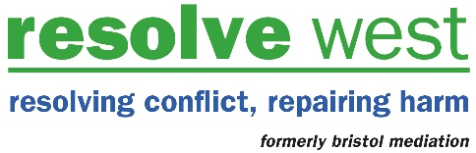

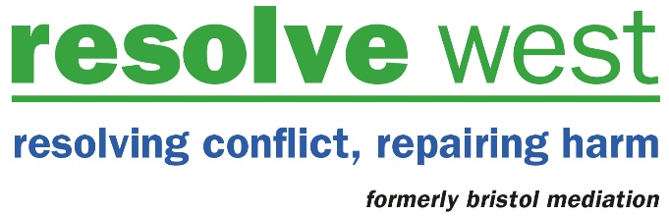

Confidential

Application for Conflict Resolution Practitioner (Hate Crime & Discrimination)

PERSONAL DETAILS

Name
Address
Postcode
Telephone
Email

Where did you hear of Resolve West?

Please tell us a bit about yourself, (you could tell us about your experience in work or volunteering, or some other life experience, or your background, your home situation or perhaps about what interests you)

Please tell us about current or previous paid or voluntary work you think might be relevant to this role.

Please tell us why you are interested in this role

Are you available to volunteer? (We work with clients during the daytime, evening and sometimes at the weekend – what times are you most likely to be available in the future? Eg. “often in the evenings” or “only ever during school hours”. We don’t need you to commit to specific times, but we do need to know that you will have time to fulfil the role.

Do you have all the qualities and skills listed on the Conflict Resolution Practitioner job description/person specification enclosed in the Application Pack?
YES / NO (please delete)

Are you able to come to the selection day and ALL of the training days? (listed earlier in this document)
YES / NO (please delete)

Are you able to travel around Bristol and surrounding areas to visit clients?
YES / NO (please delete)

Are you over 18 years old?
YES / NO (please delete)

Do you agree to commit 95 hours per year of your time for a minimum of 2 years?
YES / NO (please delete)

Please let us know who we should contact (two referees)
If you are selected, we would like to hear from two people who are able to comment on your potential to become a volunteer. These might be someone who knows you well in a work role, or someone you know personally – but not family members.

Name: |  |  | Name
Email: |  |  | Email:
Phone: |  |  | Phone:
Address: |  |  | Address:
How do you know this person? |  |  | How do you know this person?

Access Needs

Do you have a health problem or a disability that is relevant to this application? Do you have any specific requirements to help you access the training or volunteering role? Please give us details (you may prefer to contact us by phone to discuss this prior to making this application)

Data Protection (GDPR)
We take our duty to process your personal data very seriously. Our privacy statement explains how we collect, manage, use and protect your personal data. https://resolvewest.org/privacy-statement/

Declaration (see note below)*
You will be required as part of this post to undergo a Disclosure and Barring Service check under the terms of the Rehabilitation of Offenders Act (1974).

Have you at any time been convicted of any criminal offence or been the subject of a caution, a bindover, or no case to answer? YES / NO (please delete)

If YES, please give details, including nature of offence on a separate sheet.

NB: The disclosure of an offence will not necessarily be a bar to your appointment.
(you may prefer to contact us by phone to discuss this prior to making this application)
*Failure to disclose criminal convictions may result in the termination of your services.

I hereby declare that the particulars I have given on this form are correct and I understand that any falsification could give proper cause for dismissal.

Signed:
Name:
Date:

Selection and Training Dates 2020
Friday 7th February (Selection Day)
Thursday 27th February (9am - 5pm)
Friday 28th February (9am - 5pm)
Thursday 5th March (9am - 5pm)
Friday 6th March (9am - 5pm)
Thursday 12th March (9am - 5pm)
Friday 13th March (9am - 5pm)

Please complete this form and return to:

Hannah Pepper
Resolve West
Unit 40 Easton Business Centre
Felix Road
Bristol
BS5 0HE

Or Email to
hannah@resolvewest.org

Please contact the above email address or call 07714 237107 if you would like to discuss this opportunity further before you apply.

We really look forward to receiving your application. Closing date is 27th January 2020

Hannah Pepper

About Us
Resolve West (formerly Bristol Mediation) was one of the first community mediation organisations to develop in the UK, starting in 1987 (incorporated 1990). Over the past 30 years we have provided a range of restorative approaches including: neighbourhood/community conflict resolution, outreach work in communities; peer mediation in schools, published a peer mediation manual; run domestic noise counselling service; worked with young offenders working between them and the victims; worked with young people in the care system; worked with those at risk of homelessness, worked with young people involved in ASB/street conflict and gang crime; assisted with inter-agency co-operation; influenced local policy decisions; and trained hundreds of volunteers to be practitioners - some who still work with us and others who have gone off and become nationally and internationally known for their work. Our current work includes:
Neighbourhood Project - Neighbour/community conflict resolution services in Bristol, BANES, South Gloucestershire and North Somerset working alongside housing teams, police, anti-social behaviour teams, other voluntary and statutory agencies. This is through a range of conflict resolution skills including mediation, shuttle, and single party working. Bristol City Council funds the Bristol service until end of May 2021 with additional contracts in place with other housing providers.
Restorative Approaches - From 1st June 2017 we started RAAS (Restorative Approaches Avon & Somerset) working in partnership with the Police, Bristol Neighbourhood Justice Team to lead and provide RJ services across Avon & Somerset. This service is funded until 31st March 2023.
Bristol Hate Crime & Discrimination Service - This service is a partnership with other Hate Crime Services in the city: SARI, Bristol MIND, LGBT Bristol, Brandon Trust and Bristol Law Centre to provide a range of services to victim of hate crime and discrimination. Resolve West provides briefings/training as well as casework support for RJ and conflict resolution cases across the city. This project started1st July 2017 and will run to 2021 as part of Bristol Prospectus/Bristol Impact Funding.
Other Conflict Resolution Services – We provide other ad-hoc conflict resolution/restorative approaches to individuals, community groups, agencies and organisations across the region
Training – We provide regular RJ and mediation training courses throughout the year. These are currently free of charge to people who volunteer with us for a minimum of 2 years. (often these places are focussed on recruiting a diverse group of volunteers). We also occasionally run these courses on a fee basis for those that wish to train but are not in a position to volunteer with us.
Resolve West is staffed by a team of paid workers with around 45 volunteer conflict resolution practitioners and 65 volunteer RJ practitioners.

