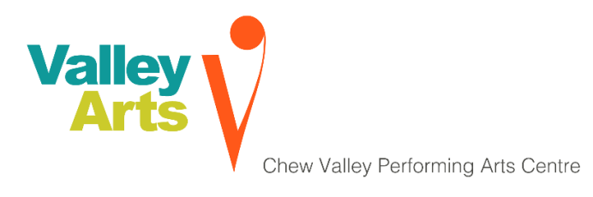

Trustee Role (non-paid)

Chew Valley Performing Arts (Valley Arts) is looking to expand its board of trustees as we move into the next phase of our development.

Valley Arts is a registered charity set up to promote the Performing Arts in all its forms among the people and communities of Chew Valley and the surrounding area. Our vision is to make the arts sustainable and accessible for all and to build a performing arts centre in the heart of the Chew Valley.

We have successfully developed a varied and challenging programme of performance over the last two years and proven that there is an audience for professional work in the Chew Valley.

Our central objective is to build a new performing arts centre for everyone in the Chew Valley and we have identified a suitable site on land at Chew Valley School. Working with the Lighthouse Schools Partnership, a multi-academy trust, we have drawn up building plans and are ready to start fundraising for a state of the art performance centre which will be used by both the local community and Chew Valley School. A funding feasibility study has been commissioned and is due to be completed by the end of the year.

About the role:
We are looking for new trustees (on a non-paid basis) to help oversee the running of the charity. The role requires between 5-10 hours each month. We have official meetings monthly in the Chew Valley that last for up to 3 hours and an Annual General Meeting (AGM) once a year. These meetings may require additional time for preparatory reading of supporting documents for presentation.
Trustees are elected to serve for a three year period. At every AGM those who have served three years retire from office or stand for re- election. Trustees are able to serve for a maximum period of three terms (i.e. 9 years).

Trustee role description
- To ensure that Chew Valley Performing Arts complies at all times with its governing document, charity law and any other relevant legislation or regulations
- To ensure that Chew Valley Performing Arts pursues its objects as defined in its governing document
- To maintain proper financial control and ensure that Chew Valley Performing Arts applies its resources exclusively in pursuance of its objects
- To set and maintain vision, mission and values, develop strategy, setting overall policy, defining goals and setting targets and evaluating performance against agreed targets
- To set up employment procedures and respect the roles of staff/volunteers
- To support the operational management of the organisation
- To draw up and monitor the implementation of internal policies, which must include equality and diversity as well as health and safety policies
- To safeguard the reputation and values of Chew Valley Performing Arts
- To maintain effective board performance and ensure the effective and efficient administration of the charity including funding, insurance and premises
- To promote Chew Valley Performing Arts and actively seek funding opportunities for the charity
- To act in the best interests of the charity, never in the interests of yourself or another organisation

Trustee person specification
All trustees must demonstrate:

- A commitment to the organisation and its aims.
- A willingness to devote the necessary time and effort.
- Strategic vision.
- Good, independent judgement.
- An ability to think creatively.
- A willingness to speak your mind.
- An understanding and acceptance of the legal duties, responsibilities and liabilities of trusteeship.
- An ability to work effectively as a member of a team.
- A commitment to working within Chew Valley Performing Arts’ values and principles of working.

How to apply
If you are interested in applying, please send some background information about yourself / a CV including why you are interested in the role to: geraldine.hillmale@valleyartscentre.co.uk
Please get in touch if you have any access needs for the application process or wish to discuss anything about the role further on 07977 059479.

