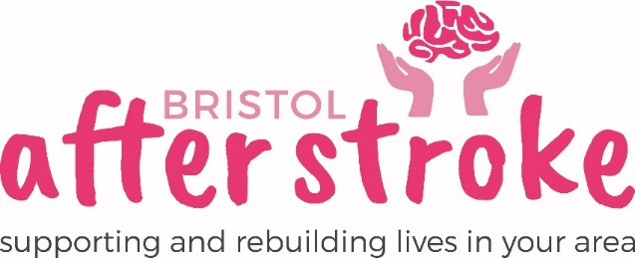

Conversation Group - Course Volunteer - Role Description

Role Title | Conversation Group - Course Volunteer
Responsible to: | Course Leader (Stroke Care Coordinator)
Time Commitment: | This 6 week course runs from Tuesday 18th February 2020 – 24th March 2020 –  10.00-12.30 each week  (We require volunteers for 2.5 hours a week)
Location: | The Station, Silver Street, Bristol, BS1 2AG
Why we need your help:
Bristol After Stroke is an independent charity helping people in Bristol, South Gloucestershire and surrounding areas to rebuild their lives. We provide information, practical support, friendship and counselling in the months and years following a stroke.

Our Conversation Group Course’s aim is to meet the needs of our members who have moderate to severe communication difficulties (aphasia and dysarthria). There will be between three and eight people in each group, with 2 volunteers and a member of staff.

The purpose of the Conversation Group is to get members talking, relaxing and laughing. It will give them an opportunity to meet others with communication difficulties and give them the chance to practice and improve their communication skills through a wide variety of activities.

Role Summary: | - Talk to group members, encourage them to get involved and generally help to promote a supportive, happy atmosphere that contributes to a sense of wellbeing.  - Provide support in group activities such as encouraging members with their communication skills ie, speaking, writing, gesture, drawing and facial expression.  - Encourage members to gain confidence and take part in activities such as board games, quizzes, photo cards and pictures etc.  - To make and serve refreshments to group members as required.  - Help at the group for its full duration each week; with set up and clear up times, this is likely to be about 2.5 hours.  - Provide help and support to the group leader and members as and when needed.
Skills and Experience: | - Be patient, understanding and have a responsible attitude.  - Know about or be willing to learn about communication difficulties.  - Know about or be willing to learn about stroke and its impact on people.  - Be comfortable working as part of a team.  - Recognise the importance of confidentiality and show this in practice.

What we can offer you:
- An induction and support and supervision in the role.
- You will be supported in your role by the Emma Eddy - Course Leader and other appropriate members of staff as needed.
- Bristol After Stroke Newsletters; keeping you up to date on charity news and other volunteer opportunities.
- You will have the opportunity to meet with other Bristol After Stroke volunteers.
- You will be able to claim reasonable travel expenses.

What we ask of you:
- To obtain 2 references from people who are not related to you.
- To keep to all the charity’s policies, values and guidelines.
- To complete an induction and any necessary training for the role.
- Be committed to good timekeeping

Bristol After Stroke
November 2019

