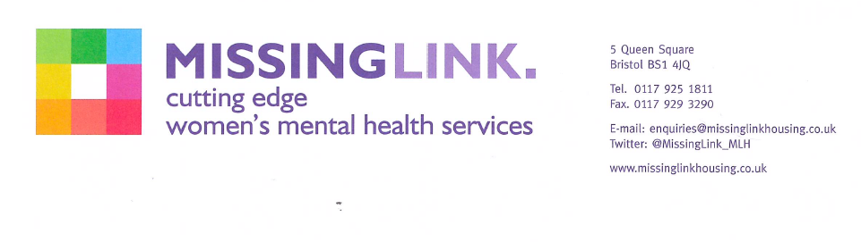

Dear applicant.

Re: Female Housing Assistant (North Somerset Services)

Thank you for enquiring about the above post.

Please find attached an Application Pack including; Job Description and Person Specification, Equalities Policy, Guidelines for Submitting an Application for a post, Application Form and an Equality and Diversity Monitoring Form.

We will be short listing on the basis of your experience and the requirements of the Person Specification. You will only be contacted if you are short listed.

CLOSING DATE: 9am, Friday 19th June 2020
INTERVIEW DATE: Thursday 25th June 2020

Yours sincerely

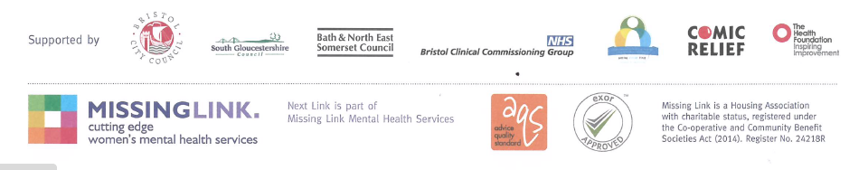
Human Resources Team

