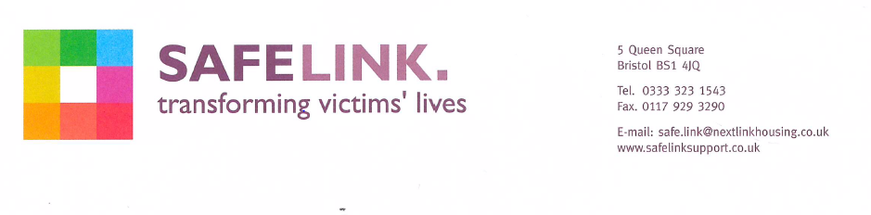

Dear applicant.

Re: Female ISVA, 37.5 hrs. per week
1 x FTC role until 31/03/2022

Thank you for enquiring about the above post.

Please find attached an Application Pack including; Job Description and Person Specification, Equalities Policy, Guidelines for Submitting an Application for a post, Application Form and an Equality and Diversity Monitoring Form.

We will be short listed on the basis of your experience and the requirements of the Person Specification. You will only be contacted if you are short listed.

CLOSING DATE: 9am Friday 14th August 2020
INTERVIEW DATE: Wednesday 19th August 2020

We look forward to hearing from you.

Yours sincerely

Human Resources

