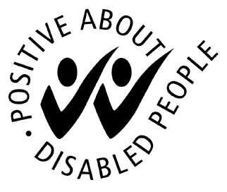
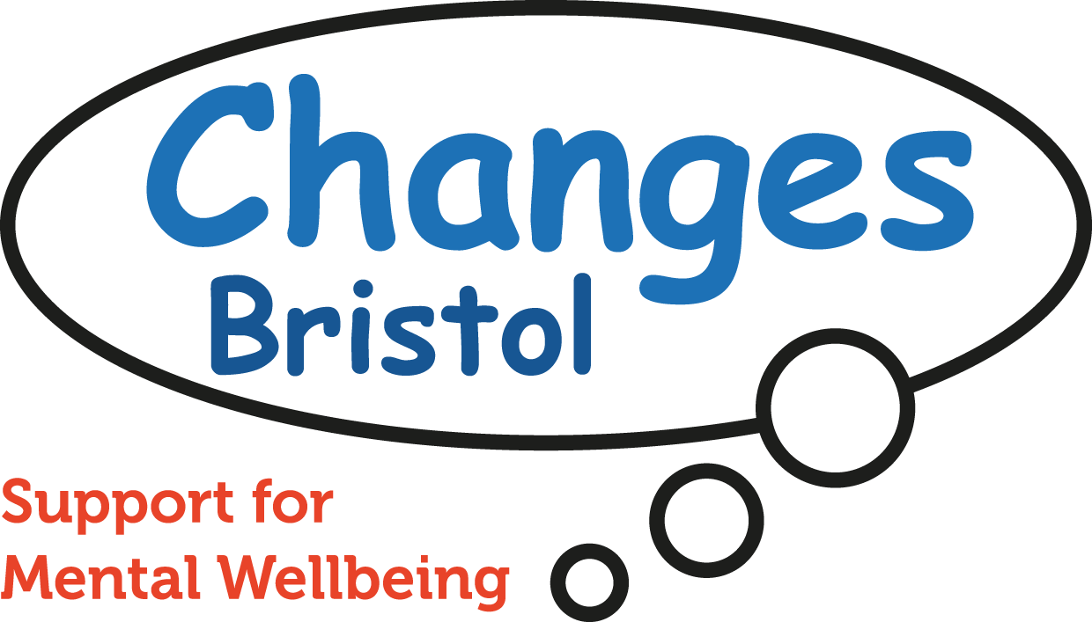
For further information as to why Changes Bristol collects this information please contact the Changes Office

Equal Opportunities Questionnaire

Changes Bristol is committed to the implementation of its Equal Opportunities Policy in all aspects of its work.
It would assist us greatly if you would complete the anonymous monitoring form so that we can monitor the effectiveness of our Equal Opportunities Policy and to find out whether there are any particular minority needs within our members, volunteers & employees.
Role | Member / Volunteer / Trustee / Employee
Age |  | 18-24 |  |  |  | 25-39 |  |  |  | 40-49 |  | 50-64 |  | 65+
Gender |  | Male |  |  | Female |  |  |  | Gender other than as assigned at birth |  |  | Prefer not to say

Please tick the boxes that you feel most comfortable with. If you do not feel any of the boxes are appropriate, please tick ‘other’ and describe in your own words. ( )

Cultural Background

White |  | Black or Black British
 | British |  | Caribbean
 | Irish |  | African
 | Other White, describe below |  | Other Black, describe below
Asian or Asian British |  | Mixed
 | Indian |  | White and Black Caribbean
 | Pakistan |  | White and Black African
 | Bangladeshi |  | White and Asian
 | Other Asian, describe below |  | Other Mixed, describe below
Chinese or Other Ethnic Group |  | Undisclosed
 | Chinese |  | Do not wish to answer
 | Any other – please describe
Sexuality

 | Homosexual |  | Bisexual |  | Heterosexual |  | Prefer not to say |  | Other

 | Buddhist |  | Sikh
 | Christian |  | No Religious Belief
 | Hindu |  | Do not wish to answer
 | Jewish |  | Other religion/belief
 | Muslim
Religion and belief
Do you consider yourself to have a sensory, learning or physical disability?
Do you consider yourself to have a disability related to your mental health?
Have you personally used mental health services?
Disability and Mental Health YES NO

 | Married / Civil Partnership |  | Single
 | Living with partner / unmarried |  | Single parent family
 | Divorced / Separated |  | Prefer not to say
 | Widow / Widower

Marital Status

Caring Responsibilities

Do you look after someone from any of the following groups? |  |  |  |  |  |  | Not Applicable
 | A child |  |  | An adult
 | Someone with a sensory, learning or physical disability
 | Someone with a disability related to his/her mental health
 | Do not wish to answer |  |  |  | Other please specify
Employment Status

How would you describe your employment status?
 | Employed |  |  | Unemployed
 | Other (please specify)
Location

Which area of Bristol do you live in?
Data Protection
The information will be kept in a database in accordance with the provisions of the Data Protection Act 1998 (which allows for sensitive personal data to be held where necessary to monitor organisations Equal Opportunities Policy). Access to information that identifies individuals will be strictly restricted and used only for implementation of Equal Opportunities policies. Employees have the right to check that information held about them is correct.

