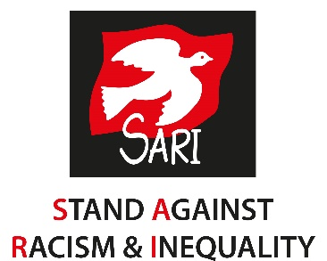

Stand Against Racism & Inequality
Equal Opportunities Monitoring

We are committed to equality of opportunity. The aim of the policy is to ensure no job applicant, employee, volunteer or service user is discriminated against either directly or indirectly on the grounds of race, ethnic or national origin, religion or belief, political opinion or affiliation, sex, marriage & civil partnership, pregnancy & maternity, sexual orientation, gender reassignment, age, disability.

Our criteria and procedures are frequently reviewed to ensure that individuals are selected and treated on the basis of their relevant merits and abilities. Equal opportunities are promoted and all employees are encouraged to progress within the organisation.

We are committed to an ongoing programme of action to make this policy fully effective. To ensure the policy is fully and fairly implemented and monitored, and for no other reason, would you please provide the information below.

This information will be treated with the utmost confidence and will be used for monitoring purposes only. No personal information such as your name or address will be used in collating statistical data.

Please note that this form is optional but we would welcome any information you feel confident to provide.

Please tick the boxes which best describe you:
Asian

☐ Indian ☐ Pakistani ☐ Bangladeshi ☐ Other

Black

☐ African ☐ Caribbean ☐ British ☐ Other

Dual Heritage

☐ White/Black Caribbean ☐ White/Black African ☐ White/Asian
☐ Other

Other

☐ Irish Traveller ☒Roma/Gypsy ☐ Middle Eastern

South East Asian

☐ Chinese ☐ Other

White

☐ British ☐ Irish ☐ Other

If you have answered other, please specify:
Click or tap here to enter text.

Gender: ☐ Male ☐ Female ☐ Other
☐ Trans ☐ (M-F) ☐ (F-M)

☐ Prefer not to answer

Sexual Orientation: ☐Lesbian ☐Gay ☐Bisexual
☐Heterosexual ☐Prefer not to say

Age: ☐16-25 ☐26-35 ☐36-45 ☐46-55
☐56-65 ☐65+

Title applied for: Click or tap here to enter text.

Date: Click or tap here to enter text.

