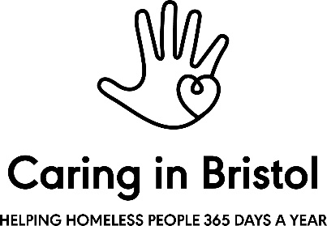

Grants and Development Coordinator – Person Specification
All criteria are essential unless otherwise stated

Attributes and personal qualities

- Creative and uses initiative. Open to challenge, embraces problem solving;
- Enthusiastic and positive, able to come up with innovative ideas and see these through into projects;
- A great communicator and team player, passionate about working with others to get things done;
- Self-confident and practical, able to take ownership and drive tasks to completion, seeking support where needed;
- Excellent attention to detail;
- Interested in community and having a positive social impact through work.

Skills and experiences

- Exceptional communication skills with a proven track record of producing a range of high-quality written materials;
- Excellent research and presentation skills;
- Experience of working in partnership with groups or organisations to achieve innovative outcomes that achieve social impact;
- Experience of developing or delivering a successful fundraising, marketing or social media campaign;
- Experience of working within a corporate social responsibility context (desirable)
- Experience of writing successful bids and grants (desirable);
- Experience of working with vulnerable people (desirable).

Other:
- A demonstrable interest in homelessness or social exclusion;
- Willingness to work occasional evenings, weekends, seasonal holidays, and be on 365 Shelter on call rota.

