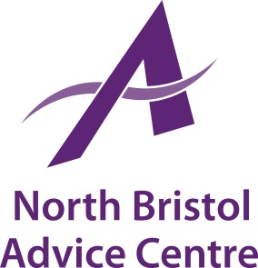

North Bristol Advice Centre is an independent charity which has been providing free and independent advice and support in North Bristol and South Gloucestershire for over 30 years. We currently have the following vacancy:

Job Title: Data Quality Officer

Grade & Salary: £22,000 pro rata (+ 4% employer contribution pension)

Salary: Up to 16 hours per week (flexi working). Occasional
evening/weekend work may be required.

Place of Work: NBAC Office, Gainsborough Square Lockleaze, Bristol, plus
outreach locations in Bristol and the surrounding areas.

Main Purpose of Job

To oversee NBAC’s data management systems. You will be expected to collate and analyse all data relating to advice contracts and ensure all monitoring requirements are met and funders reported to in an accurate and timely manner. You will ensure NBAC complies with all GDPR, Employment Law and Health and Safety Legislation. You will provide reports to the Chief Executive Officer and Board of Trustees as required.

Deadline for Applications: Friday 12th July 2019
Interviews: 24th and 25th July 2019

Contact us for an application pack:
team@northbristoladvice.org.uk or 0117 951 5751
Download from our website www.northbristoladvice.org.uk/get-involved/jobs

