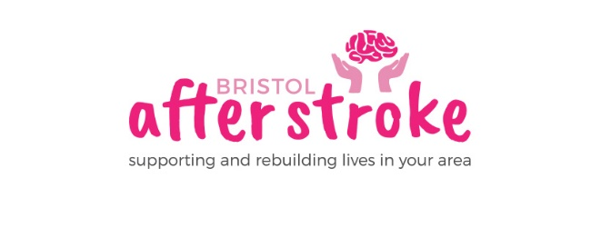
October 2019

Dear Applicant
Fundraising Officer post
Thank you for enquiring about the part time post of Fundraising Officer.
Enclosed is:
- A job description
- An application form
- An equalities monitoring form

For more information about Bristol After Stroke please go to www.bristolafterstroke.org.uk.
For any further information you might require about Bristol After Stroke or the application process, please call the office on 0117 964 7657. The office is open from 9am – 2.30pm.
If you would like an informal discussion about the post, please call myself on 0117 964 7657 or 07989 747960.
The closing date for applications is 5pm on Friday 25th October. You may send your CV and covering letter detailing how you meet the person specification of the post by email or post. Please also enclose the equities monitoring form.
Email : office@bristolafterstroke.org.uk
Post: Bristol After Stroke, The Gatehouse Centre, Hareclive Rd, Bristol, BS13 9JN
Thank you again for your enquiry. We look forward to receiving your application.

Yours sincerely
Rebecca Sheehy
Rebecca Sheehy
Chief Executive

