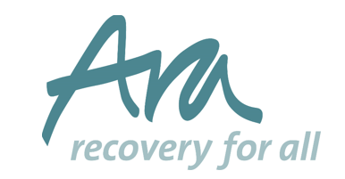
Ara’s Housing Service is part of Bristol ROADS and Bristol Homelessness Prevention pathways

1 x Maintenance Operative

Salary: Band 4 £19,439 - £22,066 per annum, pro rata

Contract/Hours: Permanent/Part time (28 hours per week)

Ara is looking for a Maintenance Operative to provide a high quality maintenance service to Ara’s housing services and offices. You will be responsible for carrying out minor repairs and maintenance tasks, painting/redecorating, preparing rooms for re-let, maintaining gardens and grounds. Full driving licence is required, vehicle will be provided.

Closing date: 9am Monday 3rd June

For more information please contact Lindsey Taylor lindseytaylor@recovery4all.co.uk
To apply, please call 0117 930 0282 or visit www.recovery4all.co.uk

In return, we offer 25 days’ leave per annum and Bank Holidays, plus an additional one day per year up to 30 days. ARA, registered charity number 1002224. ARA is working towards equal opportunities.

