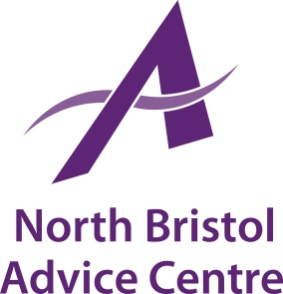

North Bristol Advice Centre is an independent charity which has been providing free and independent advice and support in North Bristol and South Gloucestershire for over 30 years. We currently have the following vacancy:

Job Title: Money Advice Mentor

Salary: 14 hours per week @ £10.00 per hour

Contract Term: Initially funded for one year

Place of Work: NBAC Office, Gainsborough Square Lockleaze, Bristol, plus
outreach locations in Bristol and the surrounding areas.

Main Purpose of Job

NBAC are seeking an enthusiastic and proactive Money Advice Mentor to work with our debt team to enhance the quality and efficiency of our debt advice service. The role involves working one-to-one with debt clients to support them to be “advice ready”, providing basic income maximisation support and completing admin tasks that will enable our specialist advisers to support more people in need. Full training for this role will be provided, but to be successful applicants must demonstrate excellent written, numerical, and administrative skills as well an ability to communicate effectively with people from different backgrounds.

Deadline for Applications: Wednesday 20th November 2019
Interviews: Monday 25th November 2019

Contact us for an application pack:
admin@northbristoladvice.org.uk or 0117 951 5751
Download from our website www.northbristoladvice.org.uk/get-involved/jobs

