FEMALE* CRISIS HOUSE NIGHT SUPPORT WORKER

Contract: Permanent
Salary: Point 9, £20,344 (pro-rata)
Hours per week: 33.5 (4 nights on/ 4 nights off)
Location: Bristol

Would you like to join the largest provider of women-only services in Bristol bringing innovation, expertise and extensive experience?

We are looking for a positive and dynamic Night Support Worker who will work in our crisis house for women experiencing a mental health crisis and who are unable to cope in the community. Crisis House provides 24 hour support to women and works to a social care model of recovery. Successful candidates will be responsible for the support and safety of our service users.

The successful applicant will have:

- Experience of support planning and crisis prevention
- Experience of working in a support or care setting with people in mental health crisis
- Experience of managing emergency situations effectively
- Be able to work shifts between 9.30pm – 7.30am on a four nights on and four nights off basis.

Benefits:

ᴑ Up to 30 days annual leave (depending on length of service) ᴑ 3 extra holidays including International Women’s Day ᴑ Excellent development and training opportunities ᴑ Employer pension contribution (minimum 5% of your gross salary) ᴑ Mindful Employer Plus Scheme ᴑ Cycle to Work Scheme ᴑ Long Service Awards ᴑ Wellness Awards ᴑ

How to apply:

Please download the application pack from our website and complete the application form. Please submit your application by 9am Wednesday 1st May 2019. Please do not send CVs. Interviews will be held on Monday 6th May 2019

enquiries@missinglinkhousing.co.uk www.missinglinkhousing.co.uk

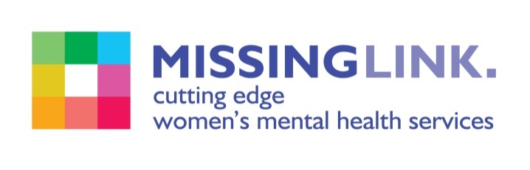
Missing Link is committed to safeguarding and promoting the welfare of children, young people and adults at risk of abuse, and expects all staff and volunteers to share this commitment. Missing Link is committed to Equal Opportunities. *All posts are exempt under section 7 (2) (f) of the Sex Discrimination Act 1975.

