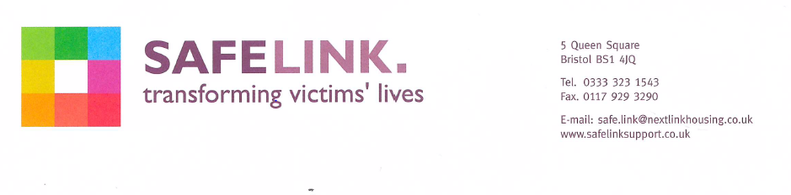
Dear applicant

ISVA’s spend some of their working week working from Police force offices across Avon and Somerset. Working from the police office the ISVA will have access to victim information held on police computer databases.

The Police are legally responsible for ensuring that the integrity of people working on or visiting Police force premises is beyond reasonable doubt, to gain that assurance they carry out vetting. This vetting is in addition to the enhanced DBS checks that every Missing Link/ Next Link or Safe Link employee has.

Police Security and Vetting Procedures

- Before a Safe Link employee can start working from a police station, thorough checks must be undertaken to ascertain whether anything is known to the detriment of that employee, her spouse or partner, or close relatives such as parents, in-laws, siblings or others living or associating with the employee.
- All ISVA employees will have to complete detailed vetting forms to enable these checks to be made.
- The police will also check whether any close family or associates are involved in criminal activity and will therefore search for any criminal convictions or cautions recorded against an employee’s family. ISVA employees undertaking this vetting process must advise people that these enquiries will be made. The police cannot disclose the results of these enquiries to you.
- The police vetting can take up to 2 months

Your offer of employment with Safe Link will be dependent on you receiving approval from the Police, following their vetting procedures that you can carry out some of your duties from police offices.

You can start in post before the vetting is complete; however should you not receive vetting approval the offer of employment will be immediately withdrawn.

Best wishes,

Nats Opitz
Human Resources

