Programme Volunteer Role Description
The Youth Adventure Trust is a registered youth development charity working with vulnerable young people aged 11 to 16 years old from Wiltshire and Swindon. Our programme provides young people with the chance to try new things and challenge themselves, experience success, learn to go beyond their expectations and grow in confidence. They have the chance to take part in a range of activities, work in a team, experience group living and challenge themselves in a new environment. The programme is built around three residential adventure camps and a series of day activities based locally in Wiltshire.
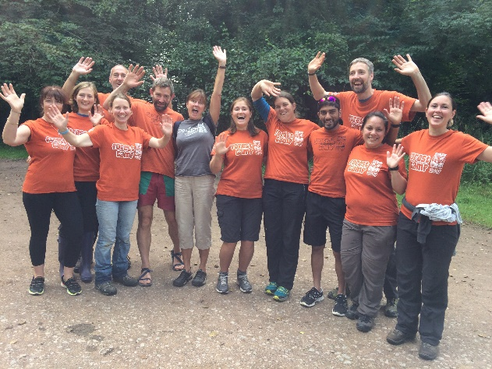
As a Programme Volunteer you will work with groups of up to 10 young people alongside other volunteers, trained members of staff and activity instructors. You will have the opportunity to take part in the activities with the young people, ensuring that they get the most out of their time on our programme.
You will ensure the welfare and organisation of the young people, help them to get involved and overcome issues, encourage and support their social relationships and help guide your team to work together.
With the support of the Youth Adventure Trust staff and other volunteers, you will help facilitate the young people’s learning and development by planning and delivering regular review sessions.
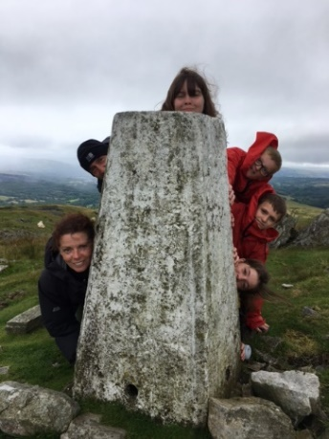
What can you bring to the role?
A wide range of experience, knowledge and skills - we really value the diversity our volunteers bring
An opportunity to raise the aspirations of young people and to broaden their world view of careers and life experiences
An interest and enthusiasm for outdoor activities and/or working with young people.
What can the role offer you?
A real sense of achievement and high levels of self-satisfaction in witnessing a group of young people develop. Pride in knowing that you have helped to give them a worthwhile and meaningful experience.
A chance to connect with like-minded people
An opportunity to advance your career, improve your CV or develop a range of transferable skills
Increased self-confidence and improved well being
An opportunity to support a cause that you believe in, and to make a significant impact through volunteering, but without a regular commitment
A chance to have fun, try new activities and to have your own adventures
Provide references for future employment

What we would like from you
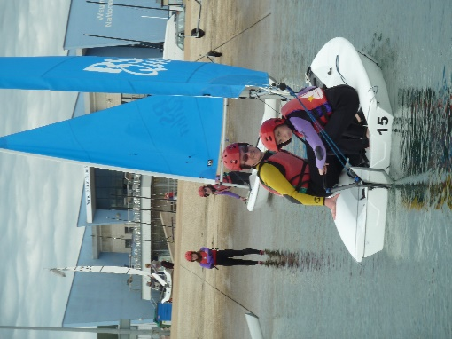
Programme Volunteers need to be resilient, enthusiastic, hardworking and willing to get involved in a wide range of activities. You should be a responsible individual and positive role model.
You will need to represent the charity with professionalism and without prejudice
Previous experience of working with young people or of outdoor activities would be beneficial, but is not essential
A commitment to attend volunteer training, which will form part of the selection process
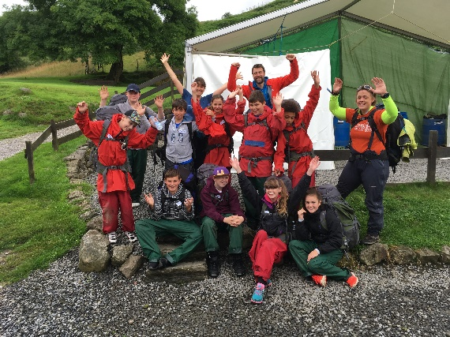
No formal qualifications are required
You must be aged over 18 years old
You will need to undertake an enhanced Disclosure & Barring Service check
You will be required to provide two references

How the Youth Adventure Trust will support you
Provide you with training through an annual volunteer training weekend, online modules and additional group or bespoke sessions.

Provide you with a Youth Adventure Trust Volunteer Handbook full of information and guidance

Reimburse any out of pocket expenses in accordance with our Volunteer Policy, and help to organise travel to activities
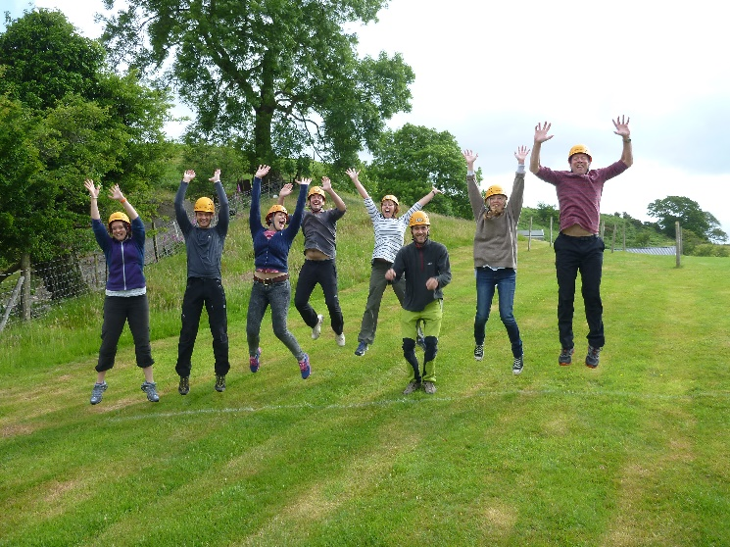
Ensure there is support from experienced, returning volunteers

Provide comprehensive information and briefing in advance of any activities, and the opportunity for debriefing afterwards

Organise volunteer social events to provide the opportunity to connect with others

Give you the full support of a dedicated Volunteer Manager

How to apply

Download and complete a volunteer application at youthadventuretrust.org.uk/get-involved/volunteer/programme-volunteers or contact Jon Rich, Volunteer Manager at jon@youthadventuretrust.org.uk or 07469 886523.

On receipt of the form we will contact your referees and also arrange to meet you in person to discuss the work of the Trust, the young people we support and the volunteer role. There will be an opportunity to share your experience and skills as well as your motivations to volunteer.

