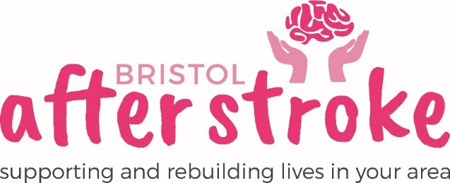

Stroke Café Volunteer Role Description

Role Title | South Gloucestershire Stroke Café Volunteer
Responsible to: | Stroke Care Coordinator
Time Commitment: | 3 hours monthly (2nd Friday of every month – 10.30-1.30pm)  Minimum of 6 months.
Location: | Downend Methodist Church, Badminton rd, Downend,  BS16 6NU
Why we need your help:
- Bristol After Stroke is an independent charity helping people in Bristol, South Gloucestershire and surrounding areas to rebuild their lives. We provide information, practical support, friendship and counselling in the months and years following a stroke.
- Our Stroke Café Volunteers provides help and support to our Stroke Care Coordinators who run a monthly drop-in café. The café gives people affected by stroke the opportunity to meet others affected by stroke, hear informative talks, meet staff and volunteers as well as find out more about the services Bristol After Stroke provide and arrange for further contact.
- We wouldn’t be able to provide this service without the support of volunteers who are helping people regain confidence after stroke.

Role Summary: | - Contribute to the atmosphere at the Stroke Café by showing warmth, friendliness and inclusivity.  - Help at the group for its full duration each week including setting up and arranging furniture and clearing away the room at the end.  - Make and serve refreshments.  - Record information on those attending the Stroke Café.  - Make sure attendees have somewhere to sit that is suitable.  - Be aware of what information is available at the monthly café and which staff are available for consultation.  - Act as befrienders and facilitators introducing people, initiating conversations and listening.  - Inform attendees of the referral process and the benefits of making a formal referral.
Skills and Experience: | - Be patient, understanding and have a responsible attitude.  - Enjoy meeting people, be sociable and at ease of making conversation.  - Be comfortable working as part of a team.  - Know about or be willing to learn about stroke and its impact on people, particularly regarding communication problems.  - Recognise the importance of confidentiality and show this in practice.

What we can offer you:
- An induction and support and supervision in the role.
- You will be supported in your role by the Stroke Care Coordinators and other appropriate members of staff as needed.
- Bristol After Stroke Newsletters; keeping you up to date on charity news and other volunteer opportunities.
- You will have the opportunity to meet with other Bristol After Stroke volunteers.
- You will be able to claim reasonable travel expenses.

What we ask of you:
- To obtain 2 references from people who are not related to you.
- To keep to all the charity’s policies, values and guidelines.
- To complete an induction and any necessary training for the role.

Bristol After Stoke
October 2018

