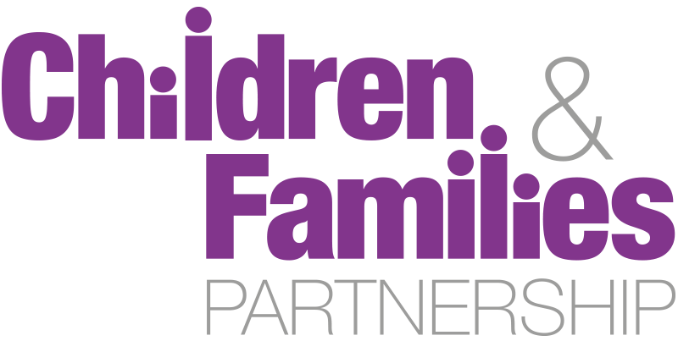
08
Fall

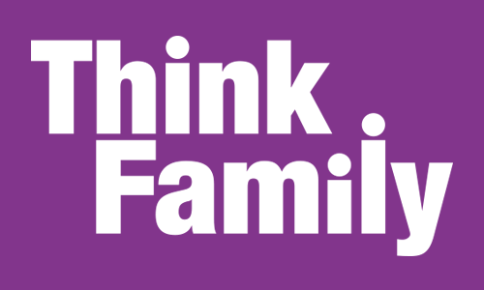

Terms of Reference
July 2016
Contact: Emily Ingle, Early Intervention and Targeted Services (Children, Young People and Families), Bristol City Council
- Purpose

The Children and Families Partnership Board is a high level strategic body focused on the planning, commissioning and delivery of services that promote the health and well-being of children and families in Bristol, and safeguard the vulnerable. It is a partnership board that aims to ensure that strategy development and commissioning activity is approached jointly in order to assure delivery of the best possible outcomes for children and young people in the city. The Board recognises the wide benefits of early intervention and prevention and prioritises the promotion of this approach across the partnership. The board has several sub groups including the Think Family group that reports to it.

- Aims and Scope of the Think Family sub group
In all of its operations, the group will aim to provide:
- Strategic direction for Think Family, including Troubled Families Funded work and Schools Forum investment
- Scrutiny of impact / performance management /efficient use of resources
- Operational problem solving and promoting integration
- Growing evidence base for high quality, whole family working

Working principles
From C&FB . . . To achieve these aims, members of the Board undertake to:

- Support the principles of prevention and early intervention – supporting families in parenting their children to secure good long-term outcomes and maximise life chances
- Prioritise outcomes for vulnerable children, young people and families
- Take an evidence-based approach to the planning, design and commissioning of our services to ensure that children and young people’s needs are met
- Aggregate and share knowledge from our collective sources of information, reducing duplication and integrating systems wherever practical
- Listen to the voices of children, young people and carers, and be open and honest in our response to them
- Ensure that we know the landscape in which we commission – by understanding the needs of children and young people and wider communities, and the pressures on service providers in all sectors
- Ensure that all commissioning decisions make the most effective use of our collective resources

- What the Group will do
The Think Family sub group of the Children and Families Partnership Board will make recommendations to the partnership board and monitor the work and performance of the groups that report to it.

The group will provide strategic leadership across the partnership by;

- Leading the strategic recognition of children affected by parental offending in Bristol
- Recommending strategic commissioning objectives to the partnership, including priorities and outcomes to support the health and wellbeing of children with a focus on Early Intervention.
- Devising a programme of work based on the identified strategic priorities and collective commissioning intentions of its membership, and will regularly report on these activities.
- Identify opportunities for the joint planning and commissioning of services across the partnership
- Scrutinising and evaluating the work of the Parenting and Family Support Delivery Group.
- Implementing effective sharing of information, resources and decision making across the partner agencies
- Ensuring that mechanisms are established for the engagement and involvement of stakeholders (children and young people, parents, carers, schools and service providers).
- Reviewing and aligning member organisations’ strategy and planning, based on needs analysis and specific requirements arising from national policy and legislation.
- Receiving performance information, intelligence, policy reviews and other information necessary to guide strategic commissioning across the partnership.

- Governance and accountability
Members of the board remain wholly accountable to their employing organisations, and thus should be sufficiently empowered to discuss and influence the strategic direction of that organisation in a partnership context.

The Board will work alongside, and from time to time may share accountability with the Health & Wellbeing Board or Local Safeguarding Children Board for key areas of work involving joint commissioning of services or needs assessment.

The minutes of Board meetings will be made public.

- Roles and Responsibilities of Members
Members of the board are expected to ensure that these responsibilities are met at all times:

- The Members of the Board (and through them the organisations they represent) will cooperate to promote the wellbeing of all children, 0-19 years of age, and may cover some provision made for young people up to age 25.

- The Board members remain individually accountable to the executives of the participating organisations or represented bodies.

- The Board will report to and make recommendations to the Children and Families Partnership Board where appropriate.

- In undertaking these responsibilities the members of the Board will ensure that it continues to:
  - Consult with appropriate forums and groups.
  - Co-opt members such as practitioners, children and young people, service providers, parents/carers as deemed necessary to provide further advice and information.
  - Ensure that the participation of children, young people and their families are integral to its work.
  - Take account of statutory guidance in developing local arrangements.
  - Oversee arrangements for effective sharing of information across the partner agencies.

- A member of the Board who is unable to attend a Board meeting may appoint a substitute to attend in his or her place provided that:
- The substitute is a member or employee of the same organisation as the person for whom they are substituting;
- The substitute has been given the same authority to represent and commit (where applicable) the organisation as the person for whom they are substituting;
- Any substitution must be a single appointment for the whole of a meeting.
- A person may not send a substitute if the Board has directed them to attend in person.

- Meetings of the Board shall be convened by the Chair. The Head of Early Intervention and Targeted Services (Children, Young People and Families) will chair meetings.

- The People Directorate will also be responsible for supporting the board and providing venues for the board to meet.

- The Board will meet six times per year initially, phasing to four times a year. The Chair may call additional meetings of the Board and shall do so if he or she receives a request from two or more members of the Board.

- The quorum for a meeting of the Board shall be 50% of the representatives set out in the membership, which must include at least one representative of Bristol City Council and the Clinical Commissioning Group.

- The Board will make recommendations to the organisations that are represented at it, and monitor the work of sub-groups that report to it.

- Membership

Membership is primarily granted to those with senior strategy and commissioning responsibility and resource management oversight in partner organisations. Members must declare any conflict of interest arising in meetings. This includes, but is not limited to, any provider functions they perform which may fall within the scope of strategic commissioning and decision-making by the Board.

In addition to the permanent members identified below, additional attendees will be asked to attend for specific agenda items or packages of work. Finance resource will be co-opted to act as liaison with the finance function and to inform discussions and decisions on financial information and reporting.

Think Family Sub Group

Permanent Voting Board Members
Head Of Early Intervention and Targeted Services (Children, Young People and Families)  (Chair) | Gary Davies | Bristol City Council
Young People’s Public Health Team Manager | Anne Colquhoun | Bristol City Council
Housing Policy & Contracts Manager | Carmel Brogan | Bristol City Council
Service Manager Integrated Service 0-25 | Carol Watson | Bristol City Council
Service Manager - Employment and Skills | Jane Taylor | Bristol City Council
Crime and Substance Misuse Service, Service Manager | Peter Andersen | Bristol City Council
Performance Improvement Advisor | Gavin Banks | Bristol City Council
Representative for Avon & Somerset Police | Rachel Williams | Avon & Somerset Police
Service Manager – Targeted Intervention | Gary Davies | Bristol City Council
Voluntary Sector Representation | Duncan Stanway | Barnardos
Voluntary Sector Representation | Fiona Castle | Action for Children
 | Graham Clapp | Department of Work & Pensions
Primary Phase Representative | Anne Rutherford | Executive Head Teacher, Filton Avenue Primary School
Secondary Phase Representative | Alison Findlay | Regional Community Partnerships Director (South West), Oasis UK
Early Years Representative | Sally Jaekle
Service Director, Early Help | Michele Farmer | Bristol City Council
 | Bonnie Curran | Bristol City Council

- Review of Terms of Reference

These Terms of Reference will be reviewed at least once every two years, or at times when the group is otherwise reviewing its constitution or activity.

