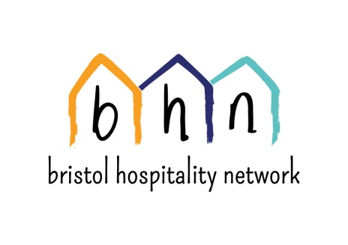
Do you want to take action to support refugees?
Do you want to work alongside refugees living locally to help make Bristol a place of sanctuary?

Bristol Hospitality Network (BHN) is looking for dedicated people to join our board of Trustees. BHN extends solidarity to people seeking asylum and experiencing destitution. We provide full board accommodation in a network of host households and in our hostel for men in Bristol , as well a drop in centre once a week which provides food, activities and advice.
We also aim to support people who are destitute asylum seekers by offering a sense of community, with practical support and volunteering opportunities.
Over seven years we have become a vibrant community of people from many nations. You can read more about our values and work at www.bhn.org.uk
We currently have a number of vacancies on our volunteer board. In particular we are looking for trustees with experience / skills in:
- Property/ Housing Management
- Business development / management experience
- Refugee Advocacy and/or experience
We would love to hear from you if you are interested. For an informal chat about the role, please contact Steve (Chair) on steve@bhn.org.uk. A detailed role description and application form can be found on our website www.bhn.org.uk
The Trustees meet every 6 weeks in Bristol (7-9pm). This role is unpaid, but as well as finding it rewarding, there's also often great food!
Closing date for applications: TBA

