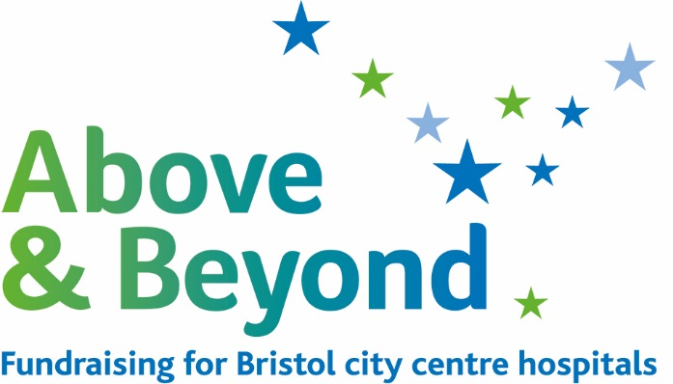

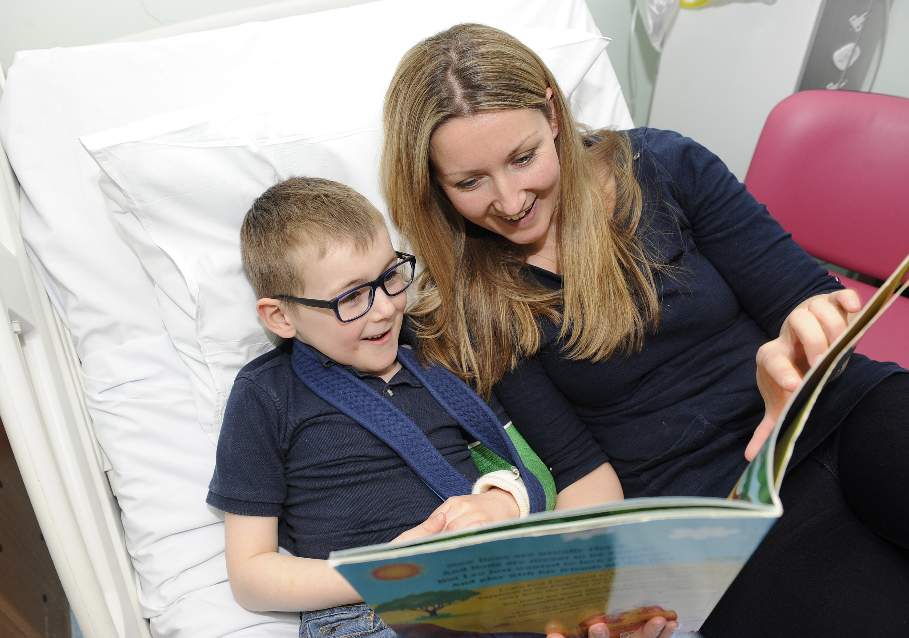

**Trustee Recruitment Pack**

**2019**

**A welcome from the Chairman**

Thank you for your interest in becoming a Trustee for Above & Beyond. We hope this Trustee role pack is helpful and informative.

We put the patient at the centre and heart of what we do and are continually looking for ways to make a patient’s experience the very best that it can be in Bristol’s hospitals and community services. We are the charity behind a lot of the state-of-the-art services and equipment being used in Bristol’s city centre hospitals and of the modern and welcoming patient and visitor facilities and environment that are run by University Hospitals Bristol NHS Foundation Trust. In 2018 our most recent Appeal to raise £830,000 for the Bristol Heart Institute, was successfully completed. This will see enhanced on site facilities and support pilots for new surgical procedures and equipment.

Formed as a charity in 1974, although philanthropy has been very much alive in Bristol’s health sector and our hospitals since 1735, the charity has been able to grant over £86 million for better patient facilities. It is very rewarding to feel that the work that our charity does and from the generosity of our donors, we are able to make such a difference to patients’ experience.

You will be coming to Above & Beyond at an exciting time of change. Despite the challenging external environment Above & Beyond continues to attract amazing support from grateful patients and their families and the wider public in the Bristol city region. As we plan for our next phase of development, there will be increasing opportunities to look across the wider health care landscape to enable us to meet our objectives of supporting and helping as many patients in our region as possible, whilst at the same time standing firmly behind our wonderful NHS staff.

We would welcome you to our Board to help us achieve this. Our Board is a collegiate one, whilst driving good governance and ensuring strong accountability, we work together as a Board and with the management team, to achieve the very best for the health of our community.

We are looking for trustees with strong governance and strategic understanding to support the management team in their running of the charity. If you have some of the skills and experience we are looking for, and have the commitment to the charity’s vision and values, I would very much like to hear from you.



Drummond Forbes Chris Monk

Chairman Vice Chairman

***About Above & Beyond***

The hospitals’ charity was formed in 1974 as part of a national initiative within the Health Act of that year to manage philanthropic donations appropriately. The NHS charity had ‘independent’ trustees but was regulated both by the Charity Commission and the Department of Health.

Historically, the charity has looked after monies that were given to support patients, managed the investment strategy, and made grants to the hospitals to improve patient experience. Since 2009, it has become a more pro-active charity, driving both an agenda of positive patient initiatives and a priority-driven and targeted fundraising strategy. The charity team works hard to draw in new money to support patient experience and to make sure that patients from Bristol and the South West get the very best treatment and care in the best quality facilities.

Within the 9 hospitals that make up University Hospitals Bristol NHS Foundation Trust, that we support, there are regional specialist centres of excellence and expertise, with some areas of medicine of national and international renown. We also support a large general hospital for the people of Bristol, and associated community services.

Each year we work hard to invest some £3 million in projects that make a real difference to every patient and every condition:

* from increasing the number of sensory facilities and toys to support sick children’s development while in hospital, to funding a new Radial Lounge in the Bristol Heart Institute, enabling patients to get less invasive treatment in comfortable settings without having to be admitted.
* from pump priming research into a drug for paediatric rheumatism which is now transforming treatment worldwide, to funding scholarships for nurses to drive new service developments through learning and post graduate study.

**Our Vision**

Working with inspirational local people, our vision is to raise funds to ensure patient care is the very best it can be in Bristol city centre hospitals.

**Our Mission**

Our mission is to make a real difference to patients, their families and the staff who treat them in Bristol city centre hospitals. With the generosity of our donors and supporters we fundraise to:

* Create welcoming environments
* Provide world class facilities and the latest technology
* Fund innovative research
* Support staff training and development

**Our Values**  
We are committed to...

* Patients first: putting the patient at the heart of everything we do.
* Respect: treating everyone fairly with respect and care.
* Excellence: in all that we fund and deliver.
* Trust: demonstrating integrity and transparency, being honest and responsible in all our work.
* Passion: being inspired to achieve the best.

**What We Do**

Above & Beyond has a strong and proud history of supporting the city centre hospitals. In 2019 the charity will celebrate its 45th anniversary and is likely to have raised close to £100million supporting not only one of the top hospitals Trusts in the UK, but having improved the experience and outcomes for many hundreds of thousands of patients and their families.

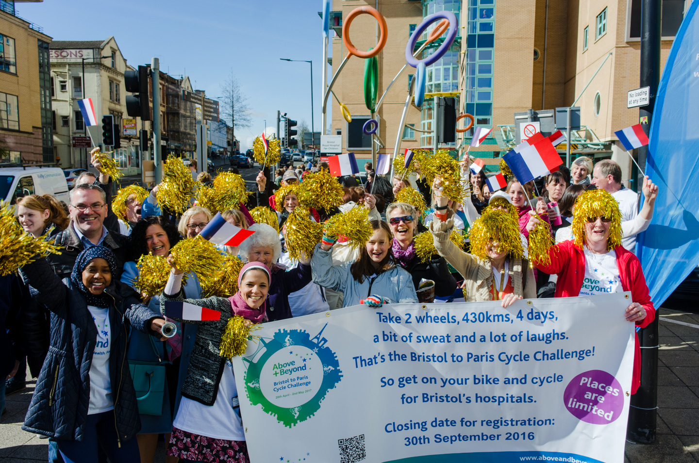

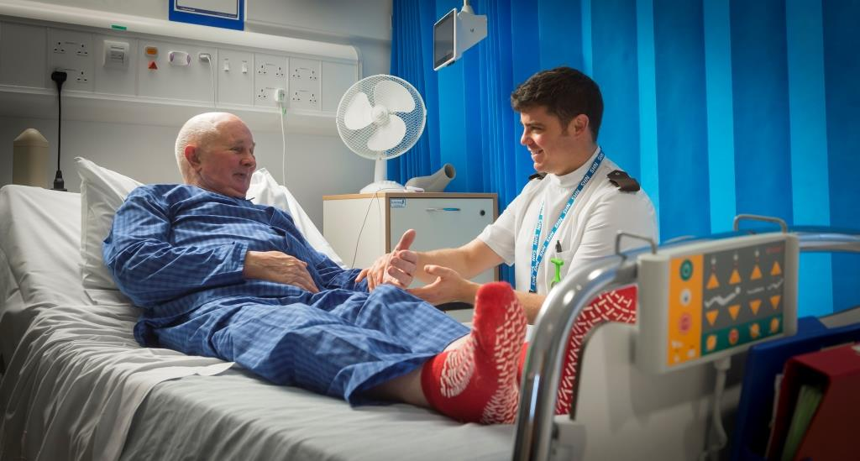

Above & Beyond’s commitment and focus is to the patient. It strives to make patients’ experience the very best it can be. Illness has no boundaries and can affect anyone. It will normally not affect just one person, but also their loved one, their families, and their friends.

Due to the nature of illnesses, for some people a visit to the hospital is unexpected and frightening; for others, it might be a place that they have to come to often and visits can be draining and endless. The charity’s commitment is to make these visits as comfortable, positive, and welcoming as possible. Dignity and privacy is important to uphold and can so easily and naturally be put at stake when ill, the charity works with the hospital to look at all ways this can be safeguarded for all patients.

The charity has transformed hospital environments to make them welcoming and positive healthcare settings.

It is also committed to making Bristol’s regional health centres the very best they can be, offering the very best treatment and care. Above & Beyond supports the development of top quality treatment and services through purchasing state-of-the-art equipment. Technology moves so fast that the need to keep up with developments requires significant investment. The most modern equipment not only helps to save and extend life, but also offers significant benefits to a patient’s quality of life.

Healthcare professionals are the key factor in the excellence of treatment and care. The charity invests in value-added training and development opportunities to healthcare staff across the board ensuring that the hospitals can recruit and retain the highest quality staff.

Research is the key to finding cure and the best treatment for any illness. As a big regional teaching hospital trust, the hospitals deliver large scale clinical trials, house clinical institutes and research units, including a new Biomedical Research Centre. The charity pump-primes research projects to drive forward a vital research agenda for quality healthcare today and transformational treatments for tomorrow. For every £1 the charity provides to research, it leverages a further £16 in research funding for the hospitals.

We are an important partner to the hospital trust and work closely with the key hospital and clinical staff to ensure that we are able to make the most of charity giving and that grant-making is strategic and maximises the benefits to the broadest number of patients.

**Our Future**

In 2014, the Secretary of State for Health announced that it was removing itself from the joint regulation of the 22 teaching hospital charities. This requires a change of legal framework and a transfer of the old charity into a new legal structure. Above & Beyond became a new independent charity, with a strong and continued commitment to Bristol’s hospitals in 2018. As the charity looks towards its future, it looks towards the health of each citizen. It will also look at what the health needs of the future are with an ageing population with more complex and chronic long-term illnesses. We will look at people’s needs in a more integrated way – whether it be in terms of looking holistically at one’s health; whether it is where treatment and care is received - in hospital or the community; or in health or social care provision.

As financial sustainability is key to Above & Beyond’s ability to make a significant difference to its beneficiaries, the charity needs to continue to drive an imaginative income generation and branding and awareness strategy and a confident and secure delivery. Different routes of income generation will need to be developed and delivered, and having ambition to develop new areas of business both within and beyond voluntary fundraising is vital. It is also very possible that its role could well diversify into the future to go beyond grant-making and establish its role as a health facilitator, or even as a service deliverer.

**How We Work**

The charity has a Trustee Board of 8-10 Trustees. The Board meets every two months to review the work of the charity, assure themselves that the charity is working towards its strategic objectives, both within the law and its own vision and mission, and supports and works as a “critical friend” to the management team. The Board also reviews major grant applications and priorities for funding. The Board sets the charity’s strategic direction and reviews its progress holding the management team to account for its delivery.

The Board is supported by the work of two sub-committees – the Audit Committee and Investment Committee. The Audit Committee is led by a Chair of Audit and has up to four Trustees on it and looks at the audit, processes and assurance for the Board. Its key role in the year is to give assurance to the board that the control environment is working appropriately and to review the charity’s annual audit and accounts process and recommend it to the Board. The Investment Committee is responsible for reviewing regular reports from the charity’s investment managers and benefits from the assistance of a Trustee who is a specialist in this area.

The Board is also supported in their work by the charity’s management team – Chief Executive, Director of Fundraising and Director of Finance, and from representatives from the Trust Executive –Executive Director Strategy & Transformation and from the University and Research Community – the Director of Research. As a Board, they act jointly, working as a team. They are committed to working to the Nolan Principles of public life and have their own code of conduct and responsibilities. The Board also has a range of professional advisors e.g. Cazenove Investment Managers, who advise and administer the charity’s investments.

1. **Time commitment**

Each Trustee needs to be able to commit sufficient time to the work. The time commitment will vary year on year, and whether the Trustee is on a sub-committee of the Board, but is normally between 6-10 days per year.

1. **Payments**

NHS Charity Trustees are unpaid and are not entitled to receive any payment out of the charity’s funds, other than reasonable ‘out of pocket’ expenses.

1. **Appointment term**

A Trustee is appointed for a term of four years, which can be extended for a further four years.

Trustees will have an annual appraisal with the Chairman to ensure that the charity is benefiting from what each Trustee can offer; to ensure positive and constructive working; and to ensure that development needs or opportunities are acted upon.

**Where you can help**

As we move forward to establishing the charity with its new strategic direction, and to balance the skills on the Board already, we are particularly looking for Trustees with knowledge and experience in Enterprise & Strategic Development, Fundraising, IT/Digital, NHS organisational and medical knowledge, and 1 Trustee to lead on the charity’s safeguarding policy. In addition to these specific skills and background, below is the Trustee role description.

**Trustee Role Description**

**Principle Purpose of the Role**

Trustees have overall responsibility for:

* Meeting the charity’s legal duties
* Ensuring that it is properly managed
* Promoting good practice in all its activities
* Ensuring that activities are in line with core objectives and strategy
* In line with the new charity commission guidance (CC20), to oversee the charity’s fundraising activities

**Key Duties and Responsibilities**

The duties of a Trustee are:

**Good Governance**

* To ensure that the organisation complies with its governing document, organisation law, and any other relevant legislation or regulations.
* To ensure that the organisation pursues its objectives as defined in its governing document
* To ensure the organisation applies its resources exclusively in pursuance of its objectives, ie, the organisation must not spend money on activities which are not included in its own objectives, no matter how worthwhile or charitable those activities are

**Strategic Direction**

* To contribute actively to the Board of trustees’ role in giving firm strategic direction to the organisation, setting overall policy, defining goals, setting targets and evaluating performance against agreed targets.
* Each trustee should use any specific knowledge or experience they have to help the Board of trustees reach sound decisions. This will involve scrutinising Board papers, leading discussions, focusing on key issues, and providing advice and guidance requested by the Board on new initiatives, or other issues relevant to the area of the organisation’s work in which the trustee has special expertise.

**Financial Responsibilities**

* To ensure the financial stability of the organisation
* To protect and manage the property of the organisation and to ensure the proper investment of the organisation’s funds
* To make sure the organisation is properly insured against all reasonable liabilities

**Acting as an Ambassador**

* To safeguard the good name and values of the organisation
* To represent the company at functions and meetings as appropriate
* To be an ambassador for Above & Beyond’s work and engage with others through networking to highlight the needs of the sector, the client base and Above & Beyond’s work.
* To keep informed about the activities of the organisation and wider issues which affect its work

**Fundraising Responsibilities**

* Ensure that the charity and its fundraising team is complying with fundraising law
* Ensure that the charity is following recognised fundraising standards
* Supervise the fundraising team and its activity, reviewing its plans
* Ensure that the charity protects its reputation and its assets

**Appointment Responsibilities**

* To appoint and support the Chief Executive and monitor his or her performance

**Other responsibilities**

* To be collectively responsible for the actions of the organisation and other trustees
* To attend meetings, and to read papers in advance of meetings
* To attend sub-committee meetings as appropriate
* To participate in other tasks as arise from time to time, such as interviewing new staff, helping with fundraising
* To abide by the equal opportunities policy
* To declare any conflict of interest while carrying out the duties of a trustee
* To ensure the effective and efficient administration of the organisation

**Person Specification**

Each Trustee must have:

* Integrity
* A commitment to the organisation and its objectives
* An understanding and acceptance of the legal duties, responsibilities and liabilities of trusteeship
* A willingness to devote the necessary time and effort to their duties as a trustee
* Strategic vision
* Good, independent judgment
* An ability to think creatively
* Willingness to speak their mind
* The ability to supportively challenge and hold the Chief Executive to account in a constructive way
* An ability to work effectively as a member of a team

General expertise and skills required from the Board of Trustees:

* Setting targets, monitoring and evaluating performance and programmes in commercial and non-profit organisations
* Financial management
* Interest in health
* Legal matters
* Property
* Fundraising
* Recruitment and personnel management, including a knowledge of employment legislation
* Public relations
* Marketing
* *Please note that the Board, in its entirety, looks to have the above skill base. It is not essential that you have all the skills above.*

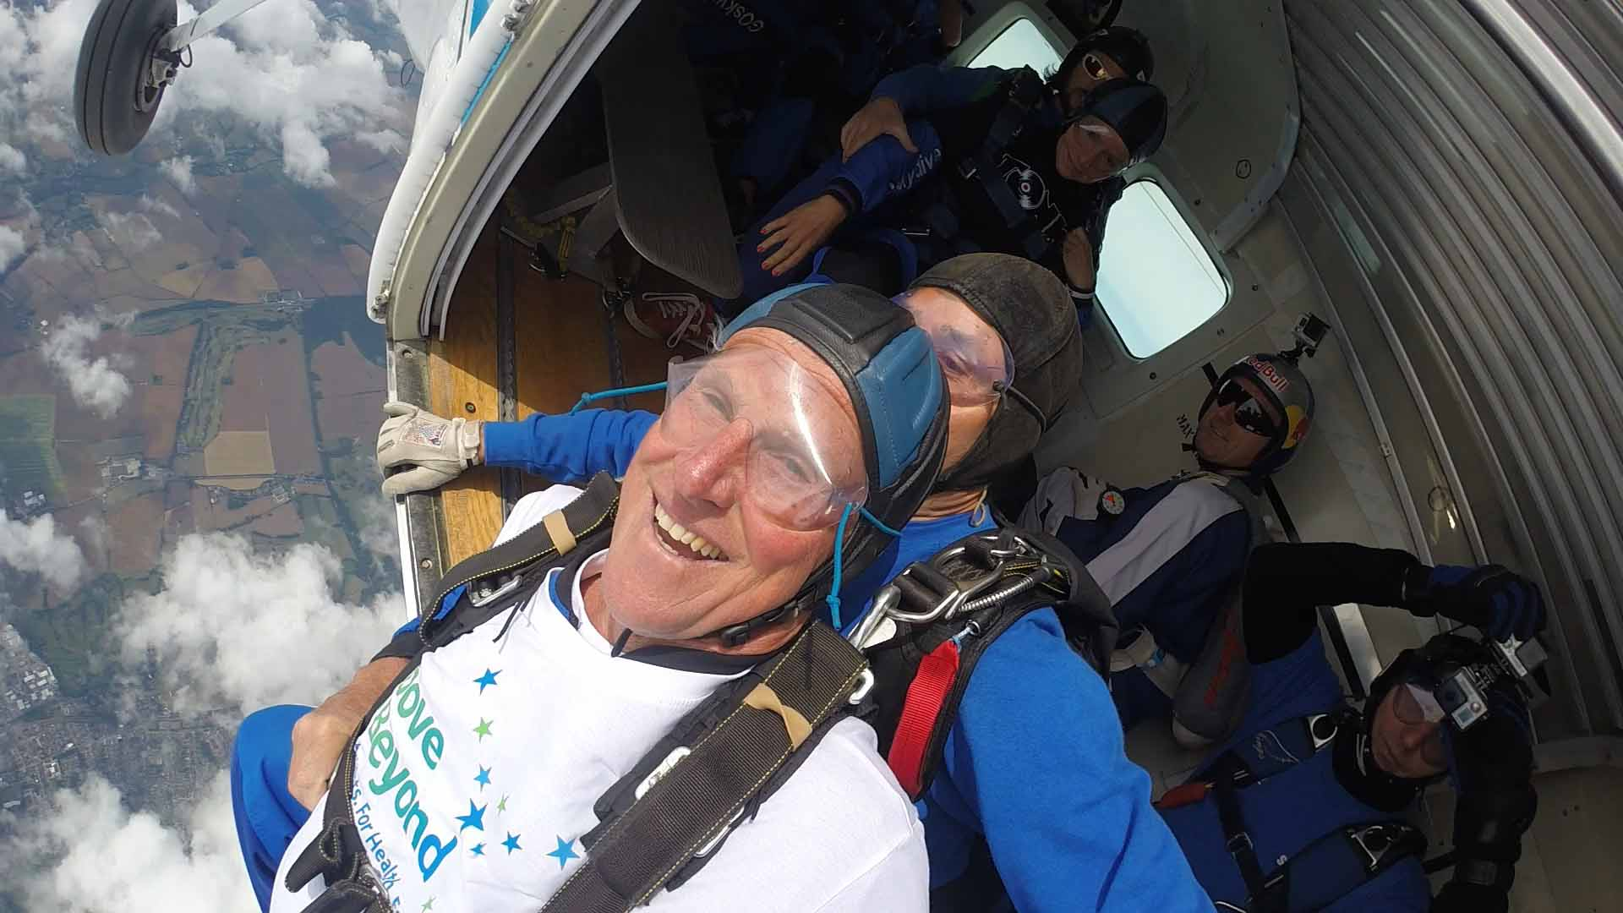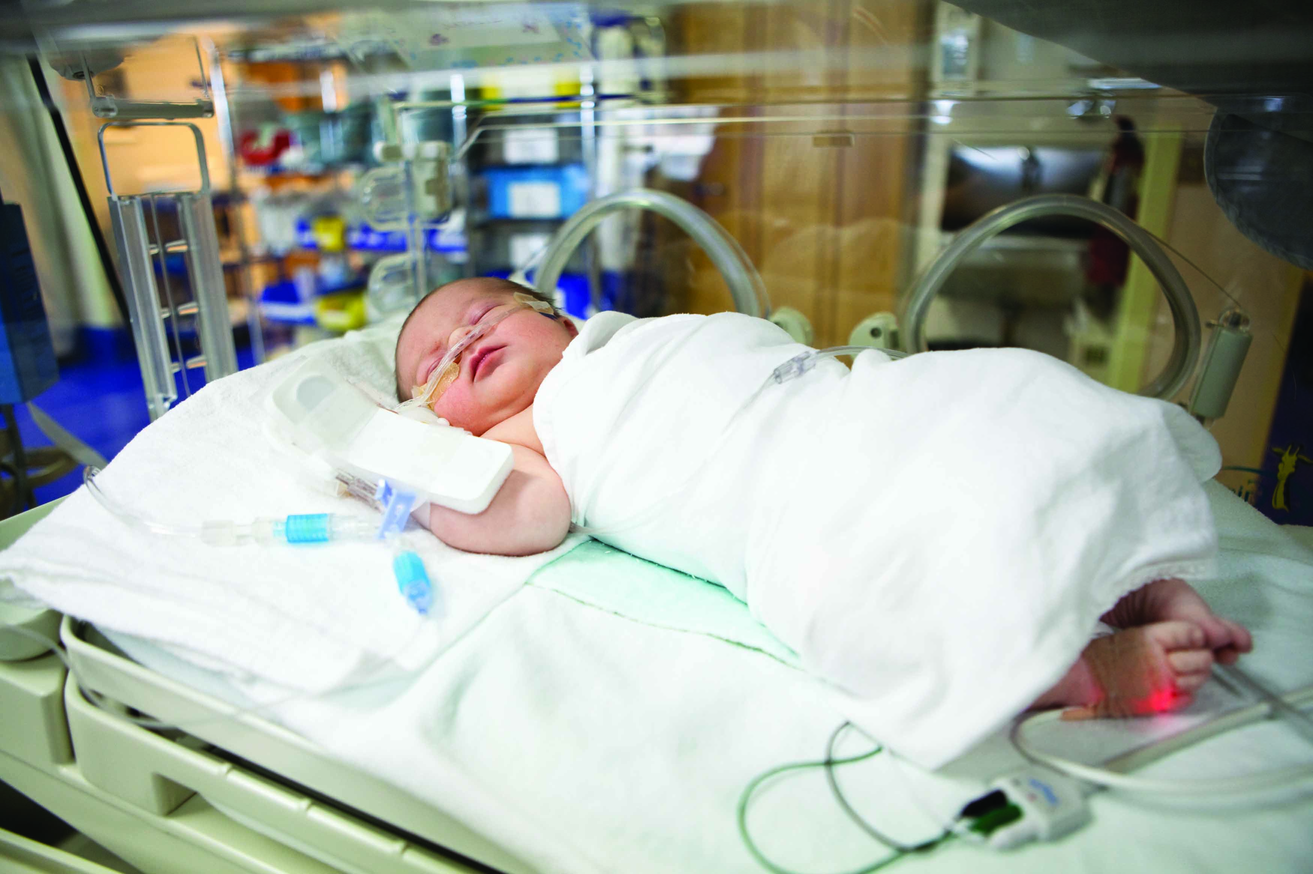

We very much hope you will be interested in applying and joining the charity’s Board. It is a very rewarding role particularly as we plan for an exciting phase of growth and development, Trustees will be able to make a significant contribution to the health of our communities in Bristol and the South West.

**How to Apply**

Please provide a brief CV together with a short covering letter outlining how you are able to contribute to the work of the Board of Trustees, particularly using the skills and experience required for the post.

**Please submit your application to reach us by noon on Friday 29 March 2019 to Paul Kearney, Chief Executive, either:**

**By post at: Above & Beyond, The Abbot’s House, Blackfriars, Bristol, BS1 2NZ, or**

**By email, directed to:** [jane.southway@aboveandbeyond.org.uk](mailto:jane.southway@aboveandbeyond.org.uk)

If you would like an informal telephone conversation with either Paul Kearney, Chief Executive, or Chris Monk, Vice Chair, please contact Jane Southway – above email or on 0117 370 0483 to arrange a mutually convenient time.

Recruitment Process

**If successful, you will be invited to have a panel interview so that you can get to know the charity and some members of the Board, and the Board members can meet with you to understand better your background and way of working.**

**Deadline for applications: Noon on Friday 29 March 2019**

**Panel Interview: Mid-April 2019 dates TBC**

**Disqualification Reasons**

You are automatically disqualified from acting as a Trustee if:

1. You have an **unspent** conviction for any of the following:

1. A **terrorism** offence
2. To which Part 4 of the Counter-Terrorism Act 2008 applies
3. Under sections 13 or 19 of the Terrorism Act 2000
4. A **money laundering** offence within the meaning of section 415 of the Proceeds of Crime Act 2002.
5. A **bribery** offence under sections 1, 2, 6 or 7 of the Bribery Act 2010.
6. An offence of **contravening a Commission Order or Direction** under section 77 of the Charities Act 2011.
7. An offence of **misconduct in public office, perjury** or **perverting the course of justice** yes/no.
8. In relation to the above offences, an offence of attempt, conspiracy, or incitement to commit the offence; aiding, or abetting, counselling or procuring the commission of the offence; or, under Part 2 of the Serious Crime Act 2007 (encouraging or assisting) in relation to the offence.

2. You are **on the sex offenders register** (ie subject to notification requirements of Part 2 of the Sexual Offences Act 2003).

3. You have an unspent sanction for **contempt of court** for making, or causing to be made, a false statement or for making, or causing to be made, a false statement in a document verified by a statement of truth.

4. You have been found guilty of **disobedience to an order or direction of the Commission** under section 336(1) of the Charities Act 2011.

5. You are **a designated person** for the purposes of Part 1 of the Terrorist-Asset-Freezing etc. Act 2010, or the Al Quaida (Asset Freezing) Regulations 2011.

6. You have **previously been removed as an officer, agent or employee of a charity** by the Charity Commission, the Scottish charity regulator, or the High Court due to misconduct or mismanagement.

7. You have **previously been removed as a trustee** of a charity by the Charity Commission, the Scottish charity regulator, or the High Court due to misconduct or mismanagement.

8. You have been **removed from management or control of anybody** under section s34(5)(e) of the Charities and Trustee Investment (**Scotland**) Act 2005 (or earlier legislation).

9. You are **disqualified from being a company director**, or have given a disqualification undertaking, and leave has not been granted (as described in section 180 of the Charities Act) for you to act as director of the charity.

10. You are **currently declared bankrupt** (or subject to bankruptcy restrictions or an interim order).

11. You **have an individual voluntary arrangement** (IVA) to pay off debts with creditors.

12. You are **subject to** a moratorium period under **a debt relief order**, or a debt relief restrictions order, or an interim order.

13. You are subject to an order made under s.429(2) of the Insolvency Act 1986. (**Failure to pay under a County Court Administration Order).**