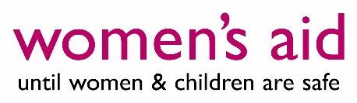
Women’s Aid Board of Trustees positions
Women’s Aid is the national charity working to end domestic abuse against women and children. Over the past 45 years, Women’s Aid has been at the forefront of shaping and coordinating responses to domestic violence and abuse through practice, research and policy. We empower survivors by keeping their voices at the heart of our work, working with and for women and children by listening to them and responding to their needs.
We are currently seeking four trustees to join our board; one of these trustees will hold leadership positions in the women’s sector as the Chief Executive or trustee of a member organisation and three positions are open to applicants who are not from a member service. Ideally we are looking for women who have commissioning, legal or financial expertise. Within this, we are also looking to recruit two Co-Treasurers.

Meeting locations London and Bristol with occasional other England-wide travel
Salary Unsalaried; honorarium payment (for members) plus out of pocket expenses, including childcare and to cover any access needs, will be paid
Closing date Midday, 24th June 2019
Interviews will be held 5th July 2019, London
Shortlisted candidates may be required to undertake an assessment in addition to interview. The successful appointments may also be subject to a satisfactory criminal records disclosure and written references.
We plan to conclude the recruitment process and announce appointments by 6th September 2019, to enable the new trustees to complete their initial induction before joining a two-day board meeting being held at the Women’s Aid office in Bristol over 21st and 22nd November 2019.
To arrange an informal conversation with one of the co-chairs about the roles or for any further information about the organisation, please contact Rachel Reed at r.reed@womensaid.org.uk or call her on 01179 157453 or 07534 620498. The recruitment pack can be downloaded from our website: https://www.womensaid.org.uk/about-us/jobs/.

