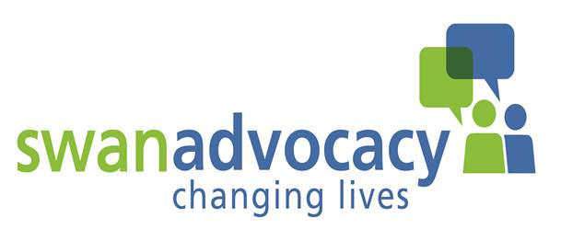


Application to become a Volunteer

Volunteer Position applied for:
1. Name:
Mrs/Mr/Other (please state)

- Address:

Telephone: Mobile:

Email address:

3. How did you hear about Swan Advocacy and VOCAS?

4. Please tell us about any voluntary work that you may have done and in what capacity, if you have no experience of volunteering, please detail why this is something you are currently considering?

- Please give details of any skills or experience you feel you could bring to the role of a VOCAS volunteer.

- Do you have a current Driving Licence, and access to a car? (Y/N)

- How much time can you commit to your volunteering role? (Days/hours per week)

- Training is provided and all volunteers will receive an induction to their role. How far are you willing to travel for training?

- Swan Advocacy provides all staff and volunteers with regular supervision. Are you willing to attend supervision when necessary and requested?

You are welcome to submit any additional information in support of your application, but it must be accompanied by this completed and signed application form.

We have a duty to ensure as far as possible that the interests of our clients are protected. For that reason we ask you to supply the names and address of two referees, people who know you well but not relatives. They should have known you for over two years and if possible one should be your present or past employer.

If you need some guidance on how to find a suitable referee, please get in touch with Elena D’Orso, the volunteer support Officer for VOCAS. Tel: 07849 352 409 or 01823 240 509.

In addition to this, all Advocacy posts are subject to satisfactory DBS checks.

Referee 1: |  | Referee 2:
Name: |  | Name:
E.mail: |  | E.mail:
Telephone: |  | Telephone:
Address: |  | Address:
Relationship: |  | Relationship:
I confirm the information given to be a true record.

Signature: |  | Date:

Please return the completed application form to: elena.dorso@swanadvocacy.org.uk

Or Post to: Elena D’Orso, Swan Advocacy, Hi Point, Thomas Street, Taunton, TA2 6HB

