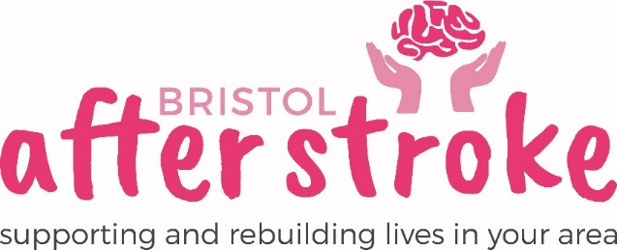

Volunteer Clerk to the Trustees
Role Description

Role Title | Volunteer Clerk to the Trustees
Responsible to: | Chief Executive
Time Commitment: | - Up to 4 hours every other month  - Meetings held 3rd Tuesday every other month 10.00am-12.00am at the offices– attendance is necessary to fulfil the role.  - Remaining work can be done at home or at the Bristol After Stroke Offices.  Minimum of 1 year
Location: | Bristol after Stroke Offices, Hartcliffe / Home
Why we need your help:
Bristol After Stroke is an independent charity helping people in Bristol, South Gloucestershire and surrounding areas to rebuild their lives. We provide information, practical support, friendship and counselling in the months and years following a stroke.
We are a small, busy organisation and we are looking for someone to provide administration support to the Board of Trustees.

Role Summary: | - Support the chair in planning and preparing the agenda for the bi-monthly trustees meeting.  - Send out agendas, minutes and other papers as appropriate to the board of Trustees.  - Take minutes at Trustees meeting, recording decisions and actions from the meetings.  - Deal with correspondence, writing letters, emails as agreed at meetings, summarising correspondence/emails received at the next meeting and drafting replies as appropriate.
Skills and Experience: | - Excellent listening, oral and literacy skills  - Good IT skills, with working knowledge of Microsoft Office.  - Experience in taking minutes  - Ability to work on own initiative  - Ability to maintain a high level of confidentiality  - Honest, committed and reliable

What we can offer you:
- An induction and support and supervision in the role.
- You will be supported in your role by the Services Support Officer and Chief Executive and other appropriate members of staff as needed.
- Bristol After Stroke Newsletters; keeping you up to date on charity news and other volunteer opportunities.
- You will have the opportunity to meet with other Bristol After Stroke volunteers.
- You will be able to claim reasonable travel expenses.

What we ask of you:
- To keep to all the charity’s policies, values and guidelines.
- To complete any necessary training for the role.

Bristol After Stoke
Feb 2019

