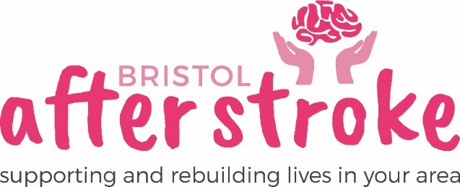

Volunteer Driver
Role Description

Role Title | Volunteer Driver
Responsible to: | Group Organiser / Chief Executive
Time Commitment: | Thursdays – 1.00pm-4.15pm  Minimum of 6 months.
Location: | We would like you to be based close to Hartcliffe - you will be driving to Port of Bristol Social Club, Nibley Road, Shirehampton, BS11 9XY
Why we need your help:
Bristol After Stroke is an independent charity helping people in Bristol, South Gloucestershire and surrounding areas to rebuild their lives. We provide information, practical support, friendship and counselling in the months and years following a stroke.

A volunteer driver is needed to take a couple from Hartcliffe to the Port of Bristol Social Club every Thursday in their own car. The couple will be attending a weekly stroke support group which runs from 1.30 – 3.45 weekly.

Role Summary: | - You will provide a safe, comfortable and reliable transport service to those who need it.  - You will transport people from their home in Hartcliffe to The Port of Bristol Social Club.  - You will remain on site for the duration of the group (between 1.30-3.45) and are welcome to either stay in your car or in the social club or attend or help at group.  - Once the group session has ended you will drive the couple back to their home.  - You will keep a record of all journeys taken and complete our expense forms each month.
Skills, Experience and Requirements: | - Full UK driving licence with 6 points or less.  - Business vehicle insurance.  (nearly all insurance companies offer this for free if you are volunteering)  - Valid MOT certificate and Road tax.  - A car with a boot big enough to fit a wheelchair in it.  - Good overall health.  - Patience and empathy.  - Good communicator.  - Recognise the importance of confidentiality.

What we can offer you:
- An induction and support and supervision in the role and any manual handling training necessary for the role.
- You will be supported in your role by the Stroke Support Group Organiser and Chief Executive and other appropriate members of staff as needed.
- Bristol After Stroke Newsletters; keeping you up to date on charity news and other volunteer opportunities.
- You will have the opportunity to meet with other Bristol After Stroke volunteers.
- You will be able to claim reasonable travel expenses.

What we ask of you:
- To obtain 2 references from people who are not related to you.
- As the Group is at a social club there will be alcohol onsite, we ask that all volunteer drivers refrain from drinking alcohol before or during their volunteering for Bristol After Stroke.
- To keep to all the charity’s policies, values and guidelines.
- To complete an induction and any necessary training for the role.

Bristol After Stoke
February 2019

