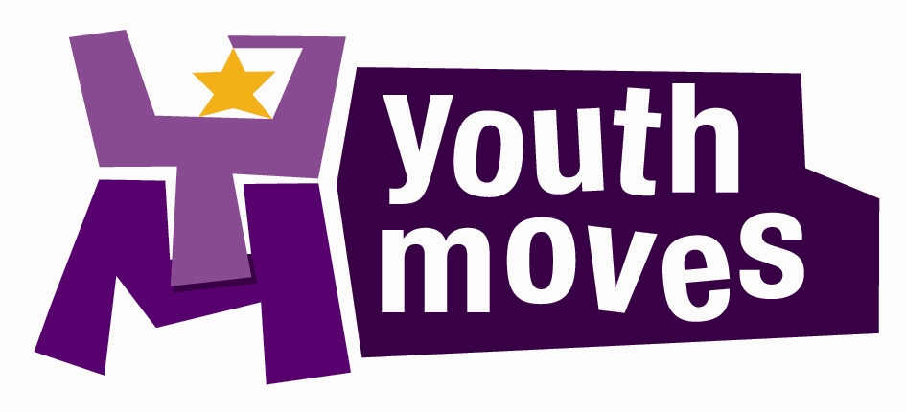

EMPLOYEE SPECIFICATION

JOB TITLE: Youth Worker L1

‘Starting Journeys, Inspiring Lives’

ESSENTIAL (Must have) | DESIRABLE (Should have)
Knowledge & Experience  A passion for the difference great youth work can make to the lives of young people, helping them to overcome barriers and make the most of their skills, whilst developing and raising their aspirations.  Ability to build and maintain strong professional relationships with young people and relevant agencies – for this role in particular we are looking for experience of:-  - Developing targeted work for girls and young women  - 1-1 caseload work with individuals at risk or referred  - Action planning with individuals to help move them forward in their lives  - Multi-agency working with partners  Understanding of the importance of Impact Measurement and the need to develop our evidence base to show the difference that great youth work makes.  Experience of maintaining good records and entering onto a database (we use the Views platform currently).  Enthusiastic, creative & energetic –Will you be positive in difficult circumstances and be able to motivate others to do the same? Are you creative and able to think on your feet to adapt a session to meet the changing needs of the group?  Either possession of a Youth Work degree or equivalent qualification from teaching/college, social work, youth offending background, or hold the L3 youth work qualification and a wealth of varied experience in youth work settings without the degree will be considered.  Understanding and awareness of the importanace of Health and safety - including Risk assessments.  Financial planning – ability to work within agreed budgets and maintain good records for financial accounting purposes.  Willingness to learn – Evidence of personal development. We value workforce development and have an expectation for all staff to attend training and continuous professional development.  Experience of working in a challenging area with young people for 2 years as a minimum.  Planning & delivery – experience of putting together and delivering high quality activity programmes for young people that help them to develop personally and learn life skills.  Experience and understanding of Safeguarding best practice and child protection issues.  Abilities & Aptitudes  Not wanting a 9-5 job - understanding that young people have most time on their hands in the evenings, on weekends and during holidays so that is when the majority of our programme operates.  Team work - Demonstrate the enthusiasm, initiative and self-motivation to work effectively within a busy team and to work independently.  A commitment to, and thorough understanding of, equality issues | Knowledge & Experience  Previous experience of delivering any of the following:  - Youth work delivery in schools/ education settings  - Detached/ outreach youth work  Staff/ volunteer supervision – help us to inspire the next generation of staff. Experience of providing positive supervision to both young volunteers and junior staff.  Understanding of the South Bristol area and some of the challenges facing young people growing up in the area  Experience of using digital technologies and social media to promote delivery and maintain contact with young people and partners.  Abilities & Aptitudes  Full clean UK driving licence – preferably with minibus driving category D1 and/ or MIDAS licence
SPECIAL CONDITIONS:
The post holder must be aged 18 or over.
The nature of your duties requires that you work at various locations around South Bristol and the wider community including youth clubs, schools, street- based work, offices and other venues as required.
This post is subject to satisfactory clearance of an enhanced level check through the Disclosure & Barring Service (DBS).

