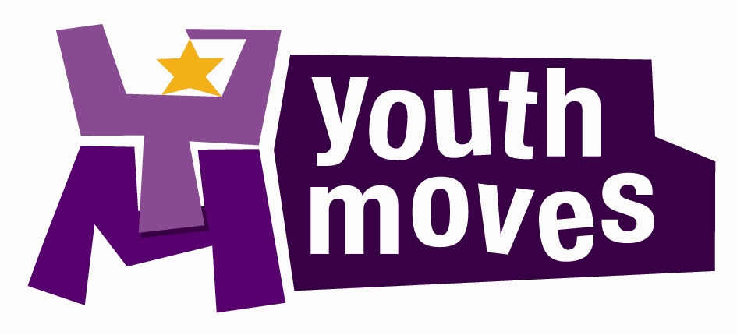

JOB DESCRIPTION

‘Starting Journeys, Inspiring Lives’

JOB TITLE: Youth Worker L1 (Targeted Youth Services – Girls Work focus)

GRADE: Pay Scale 13-13a (£24,148 - £24,684) - opportunities for progression

HOURS: 1 x full-time post available – 37 hours per week

Work hours are not 9-5 and will involve working 1-2 evenings and may occaionally include some weekends for residentials etc.

REPORTS TO: Senior Youth Worker

RESPONSIBLE FOR: Sessional Youth Support Worker staff, Apprentices, Volunteers

Purpose of the Job

Under the direction of the Youth Moves Board to deliver outstanding youth work opportunities that improve the lives of young people from South Bristol aged 8-19 years old (up to 25 for those with additional needs).

Key Job Outcomes

1. To ensure young people are in the lead, by actively promoting and encouraging their participation, taking of responsibility and engagement in all aspects of design, delivery, and evaluation of the programmes delivered.

2. To lead an area of one or more youth work responsibilities for the team as a whole.

For these posts we are looking for staff to take on the following areas of work:
- Manage a caseload of referred young people (mostly girls and young women) aged 11-19 (up to 25 for care leavers) and support them to make progress against an agreed action plan
- Deliver targeted small group work sessions for identified groups of vulnerable young people
- Support the delivery of our community youth club provision
- Ensure we meet the targets as set out in our Targeted Youth Services contract

- To keep up-to-date with training and actively look for new training opportunities and continuous professional development to be the best youth worker that you can be.

- To help build the evidence base for the youth work that we deliver and to take an active role in monitoring and evaluation, impact measurement and to analyse our results to help us to continually improve.

- To work with the team in planning, delivering and evaluating our overall Youth Moves programme of activities so that it achieves our outcomes as agreed.

- To develop partnership working to enhance the opportunities available to the young people we work with.

- To work within budget constraints and ensure all financial administration is completed.

- To capture the achievements and progress of the young people and the project, using IT systems where appropriate (Youth Moves uses the Views platform and the City Council ask us to use the EYES database for all 1-1 work).

- To ensure that all activities are carried out in accord with all Youth Moves policies – particularly Youth Moves Health, Safety & Wellbeing and Safeguarding policies and procedures.

- To promote equal opportunities in the provision of the service and take positive steps to counter discrimination.

- To undertake day-to-day supervision responsibilities for motivation, retention, and development of staff and volunteers.

Qualifications & Experience

The post holder should possess a recognized Youth Work degree qualification or equivalent qualification from teaching/college, social/ health work, youth offending background or similar (or on a course nearing completion).

Or a wealth of relevant experience in youth work settings without any of the above qualifications may be accepted – this will need to be clearly evidenced through the application process.

Have a minimum of 2 years relevant experience of working in a youth work setting.

