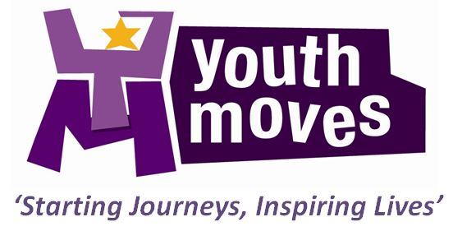

JOB ADVERT

(Full job paperwork and details/ application form can be found on Voscur Jobs page)

JOB TITLE: Youth Worker (Targeted Youth Services – Girls Work Focus) Level 1

GRADE: Pay Scale 13-13a (£24,148 - £24,684) - opportunities for progression

HOURS: 1 x full-time post available – 37 hours per week
Work hours are not 9-5 and will involve working 1-2 evenings and may occaionally include some weekends for residentials etc.

Youth Moves are looking to build our staff team and find great people to help us achieve our vision of inspiring the lives of young people in South Bristol through outstanding youth work.

Following Bristol City Council’s commissioning of their Targeted Youth Services contract we are delighted to be a sub-contractor to Creative Youth Network in delivering the South Area contract.
As a result of an internal promotion we have a vacancy for an experienced Youth Worker to enhance and develop our targeted youth work offer to young people.

The job will involve:
- Managing a small caseload of young people aged 11-19 (mostly girls and young women) who have been referred for one-to-one support based on their identified needs and agreeing action plans with these young people to help move them forward in their lives;
- Delivery of small targeted group work, this could be through our schools and education- based programmes, or in community youth club settings;
- Support of our core community youth club programme;
- Providing a response to emerging needs across the area;
- Showing the impact of the work you deliver through data capture of the work delivered on the Bristol City Council EYES database and our Views database platform.

You will be engaging with hard to reach, targeted young people supporting them to learn new skills, behaviours, resilience and helping them to make positive choices about their futures. In addition to this you will be promoting emotional, psychological and social wellbeing identifying each individuals personal barriers and supporting them to find potential solutions whilst building confidence, self-esteem and self-efficacy. This will be through 1-1 action planning and small group delivery.

Initially this contract will run until 31st May 2021 with the possibility of a 2 year extension Creative Youth Network are having ongoing discussions with Bristol City Council around this and we expect to hear quite soon, things look positive at this stage.

The job will be based with the rest of our core team at The Park Centre in Knowle.

Background to Youth Moves

Youth Moves is a youth work charity that believes passionately in the difference great youth work relationships between young people, aged 8-25 years old, and youth workers can make to the lives of young people as they grow up.
We work with young people, families, schools and communities across South Bristol, but specifically target work with groups and individuals within those communities who need our help the most.

Many of the communities we work in are within the most deprived within the UK, but we aim to focus on strengths and to build upon these enabling young people to take responsibility for their actions, make positive choices and do things for themselves, so that ultimately their lives are changed for the better.

We provide a range of services including youth club provision, one-to-one mentoring, youth participation programmes, targeted outreach and group-work, positive activities and social action/ volunteering opportunities.

Youth Moves aims to intervene early where possible and to provide long-term opportunities and pathways, working with clear evidence of need and agreed success criteria. We have been nationally recognised for the impact that we make most recently as the winner of the CYP Now Youth Work Award in 2015, but we are proud of being local and rooted in our community.

Our goal is to support young people to make a successful transition to adulthood, through providing high-quality programmes and interventions that help them to make a long-term difference to their lives.

We are looking for enthusiastic and passionate staff who are committed to the impact that youth work can play in making a difference to the lives of young people, putting young people in the lead to develop and shape these services, and building the evidence base for great youth work.
PLEASE EMAIL COMPLETED APPLICATION DOCUMENTS TO

claire.hodge@youthmoves.org.uk

Please note CVS are not accepted. To apply we need the completed application form and separate further information sheet explaining how your skills and experience match the Essential and Desirable Criteria in the Employee Specification and how these will ensure you meet the key outcomes of the role as described in the Job Description.

Recruitment Timescale

Application deadline - 9am Tuesday 1st September 2020

Interviews scheduled - w/com 14th September 2020

Planned Start Date - ASAP after the interviews are held

