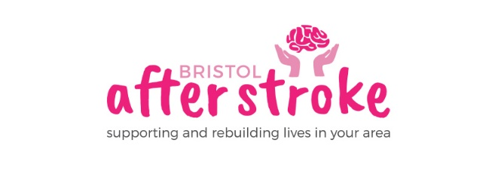
July 2020

Dear Applicant

Stroke Group –Virtual Group Organiser

Thank you for enquiring about the part time post of Virtual Stroke Group Organiser.

Enclosed is:

- A job description
- An application form
- An equalities monitoring form

For more information about Bristol After Stroke please go to www.bristolafterstroke.org.uk.

For any further information you might require about Bristol After Stroke or the application process, please call the office on 0117 964 7657

If you would like an informal discussion about the post, please call myself on 07989 747960.

The closing date for applications is 5pm on Friday 21st August . Please email your application to office@bristolafterstroke.org.uk. We are unable to accept written applications sent into the office as the office will be closed for two weeks over August.

Please make sure that you complete the application form.

Thank you again for your enquiry. We look forward to receiving your application.

Please note that if you are shortlisted interviews will take place on Wednesday 2nd September and will most likely take place over zoom.

Yours sincerely
Rebecca Sheehy
Rebecca Sheehy
Chief Executive

