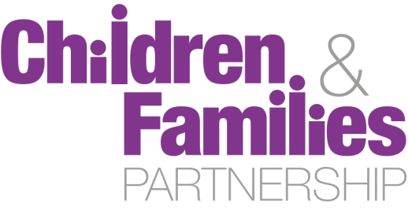

Special Educational Needs and Disability Partnership Group

Terms of Reference
Version: 2.7

Date: 10th June 2016

Contact: John Baker (0117 35 25327) or Bonnie Curran (0117 35 74474)





- Purpose

  - The Bristol SEND Partnership Group is a sub-group of the Bristol Children and Families Partnership Board focused on improving outcomes for children and young people and their families with Special Educational Needs and Disabilities (SEND). The Group will ensure the timely implementation of the changes to services and spirit as demanded by the revisions to the Children and Families Act 2014 and SEND Code of Practice set out in the Bristol SEND Improvement and Development Plan 2015 - 2016. The Group will also share any new commissioning or service redesign plans relating to SEND at an early stage and look to maximise opportunities for joint commissioning in partnership. The implementation period ends in April 2018 so there will be plans at least until that time.

  - The Improvement and Development Plan has been developed to incorporate current improvement activity, with additional coordinated action across relevant services, to respond to the SEND reforms set out in the revised legislation as well as guidance published by the Department for Education and inspectorates with the mandate to assess Local Authority readiness and progress against the reforms.

  - The group will oversee all work relating to SEND, other than that where oversight clearly belongs at another group (e.g. safeguarding). This includes the full, broad scope of SEND services (e.g. the Local Offer, Social Communication and Interaction Needs Pathway, developing the Interaction Needs Pathway Plan, Schools Forum).

  - The group will also actively seek to support related service development and review work, such as Early Years Inclusion, Youth Offending Team commissioning, Sensory Support and Alternative Learning Provision.

- Aims and Scope

  - Across all of its functions, the Group will aim to:
- Promote the needs, aspirations, choice and control and reflect concerns of children and young people with SEND and their families across all member organisations
- Plan strategically, taking a whole system approach for the health and well-being of children and young people with SEND and their families
- Align resources, knowledge and expertise across organisational boundaries
- Improve the evidence base and timeliness of decision making across the partnership by removing barriers to innovation and joint working
- Collectively challenge and support services, across the partnership, providing strategic drive via robust performance management
- Seek opportunities to achieve the best possible value for money, and to create opportunities to invest in new ways of delivering our responsibilities
- Maintain links with operational delivery across all member organisations via the Children and Families Board structure of groups.

- Working principles

  - To achieve these aims, members of the Group undertake to:
- Support the principles of prevention and early intervention – supporting families in parenting their children to secure good long-term outcomes and maximise life chances and independence
- Prioritise outcomes for vulnerable children, young people and families
- Take an evidence-based approach to the planning, design, commissioning and delivery of our services to ensure that children and young people’s and families’ needs are met
- Aggregate and share knowledge from our collective sources of information, reducing duplication and integrating systems wherever practical
- Listen to the voices of children, young people and carers, co-produce wherever possible and be open and honest in our response to them
- Ensure that we know the landscape in which we commission and deliver – by understanding the needs of children and young people and wider communities, and the pressures on service providers in all sectors
- Ensure that all decisions make the most effective use of our collective resources

- Governance and accountability

  - Members of the Group remain wholly accountable to their employing organisations, and thus should be sufficiently empowered to discuss and influence the strategic direction of that organisation in a partnership context.
  - The Group is jointly chaired by the Service Directors for Education & Skills and Care & Support – Children & Families. The Group will report directly to the Children and Families Partnership Board.
  - Reporting will also take place, where appropriate, to the People Directorate Leadership Team, the People Scrutiny Commission and the Cabinet.

- Membership

Bristol SEND Partnership Group
Members
Service Director Care & Support (co-chair) | Hilary Brooks | Bristol City Council
Service Director Education & Skills (co-chair) | Paul Jacobs | Bristol City Council
Deputy Service Director Care & Support | Angela Clarke | Bristol City Council
Service Manager 0-25 Service | Carol Watson | Bristol City Council
Service Manager (Head of Specialist Education and Access) | Annette Jones | Bristol City Council
Strategic Commissioning Manager | Rebecca Cross | Bristol City Council / NHS Bristol CCG
Service Manager First Response & Early Help | Richard Lingard | Bristol City Council
(Interim) Service Director Early Help | Michele Farmer | Bristol City Council
Service Manager Early Years | Sally Jaeckle | Bristol City Council
Bristol Parent Carers Rep | Caroline Temple-Bird | Bristol Parent Carers
Educational Psychology Rep | Vikki Jervis | Bristol City Council
VCS Rep | tbc | tbc
FE / Post-19 Rep | tbc | tbc
Adult Learning Disabilities Board Rep | tbc | tbc
SENDIAS Rep | tbc | tbc
CCHP Rep | Joanna Smith | CCHP, NHS UK

  - Membership is primarily granted to those with senior strategy and commissioning responsibility and resource management oversight in partner organisations. Members must declare any conflict of interest arising in meetings. This includes, but is not limited to, any provider functions they perform which may fall within the scope of strategic commissioning and decision-making by the Group.
  - In addition to the members identified above, additional members will be asked to attend for specific agenda items or to update on the progress of specific actions.

- Roles and responsibilities of members

  - Members of the Group are expected to ensure that these responsibilities are met:
  - The Members of the Group (and through them the organisations they represent) will cooperate to promote the wellbeing of all children and young people with SEND.
  - The Group members remain individually accountable to the executives of the participating organisations or represented bodies.
  - The Group will report to and make recommendations to the Children and Families Board, the Council, the Bristol Clinical Commissioning Group and other participating bodies, and the Health and Wellbeing Board and Bristol Safeguarding Children Board where appropriate.
  - In undertaking these responsibilities the members of the Group will ensure that it continues to:
- Consult with appropriate forums and groups
- Co-opt members such as practitioners, children and young people, service providers, parents/carers as deemed necessary to provide further advice and information
- Ensure that the participation of children, young people and their families are integral to its work
- Take account of statutory guidance in developing local arrangements
- Oversee arrangements for effective sharing of information across the partner agencies.
  - A member of the Group who is unable to attend a Group meeting may appoint a substitute to attend in his or her place provided that:
- The substitute is a member or employee of the same organisation as the person for whom they are substituting
- The substitute has been given the same authority to represent and commit (where applicable) the organisation as the person for whom they are substituting
- Any substitution must be a single appointment for the whole of a meeting
- A person may not send a substitute if the Group has directed them to attend.
  - Meetings of the Group shall be convened by the Chair.
  - The Group will meet six times per year. The Chair may call additional meetings of the Group and shall do so if he or she receives a request from two or more members of the Group.
  - The quorum for a meeting of the Group shall be 50% of the representatives set out in the membership, which must include at least one representative of Bristol City Council and the Clinical Commissioning Group.
  - The Group will make recommendations to the organisations represented at it.

- Our Arrangements for Governance and Evaluation

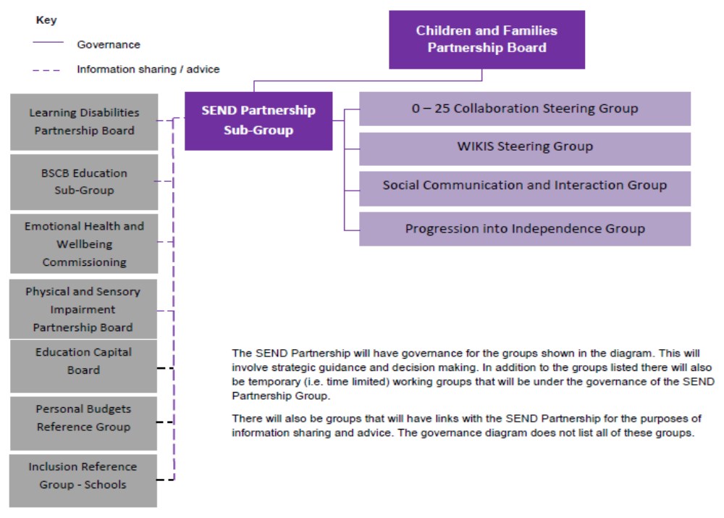

- Review of Terms of Reference

  - These Terms of Reference will be reviewed at least once every two years, or at times when the Group is otherwise reviewing its constitution or activity.

