PRESS RELEASE: Friday 20 October 2017
For Immediate Use

Materials for use:

Download a film of Bristol Coach Core representatives attending announcement at London Stadium: https://www.dropbox.com/sh/qzmwfko6kkc4y93/AABJ03nYgUmGcL-UKSNTh7HNa?dl=0

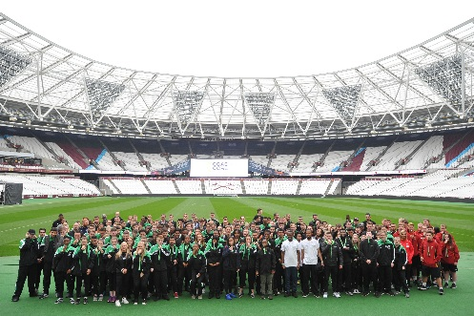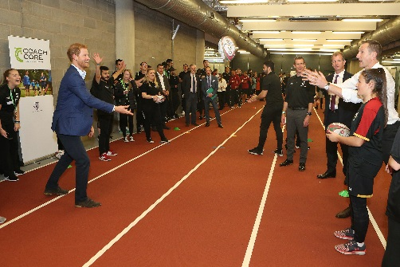

THE ROYAL FOUNDATION ANNOUNCES NEW SPORTS COACHING APPRENTICESHIP SCHEME FOR BRISTOL
The Royal Foundation of The Duke and Duchess of Cambridge and Prince Harry has announced that Bristol will be one of three new cities to offer Coach Core, the innovative sports apprenticeship scheme launched by The Royal Foundation during the London 2012 Games.
The Duke and Duchess of Cambridge and Prince Harry joined 150 Coach Core apprentices from cities across the UK in the London Stadium yesterday to celebrate the success of the project in helping young people develop solid career paths in sports coaching and go on to deliver quality training and mentoring in their communities.
Speaking at the celebration Prince Harry commended the achievements of the 250 Coach Core apprentices to date and welcomed the expansion of the programme.
His Royal Highness Prince Harry said: “Coach Core currently operates in seven cities across the country. But such is the demand for these highly skilled coaches that I am delighted to announce that The Royal Foundation will be expanding our investment in the programme. Today we are launching three new Coach Core programmes in: Middlesbrough, Devon, and Bristol.
“Working with leading organisations in the sector and partners across a number of cities, we set out to put groups of young people through an intensive year-long course in high quality sport coaching, life skills and mentoring.
“Our aim has been to create the next generation of exceptional sport coaches who are giving back to the kids in their own communities – who in turn will become leaders, mentors and role models themselves.”
Coach Core is designed to provide a solid career path to young people at risk of falling in the cracks between employment and education and of the 148 graduate apprentices, 98% are in employment or education.
Bristol will join Devon and Middlesbrough as new additions to the cities and areas offering Coach Core 2017, alongside Manchester, London, Essex, Nottingham, Birmingham, Glasgow and South Wales. Young people in these 10 cities and areas have the opportunity to learn skills vital for sport and life through high-quality teaching and mentoring and go on to provide coaching themselves in their local communities.
Applicants wishing to join the new Coach Core project in Bristol, which starts in November 2017, should email info@wearecoachcore.com, or visit www.wesport.org.uk/coachcore for further information.

Further Information if needed:

Gary Laybourne, Coach Core Project Manager said: “Since launching during the London 2012 Games we have tried and tested our innovative approach to creating the future of sports coaching and are ready to roll it out to more cities and areas across the UK.
“Young people in Bristol who perhaps are not looking ahead with confidence to work or education will now have the opportunity to forge a career path as a sports coach. Sports and leisure employers in Bristol will now be able to plan for a new wave of highly-skilled coaches to help them provide coaching and mentoring that makes exercise and sport open and enjoyable to everyone, whatever their ability.”
Facts and Figures:
To date, 98% of Coach Core graduates have gone in to work or education.
Since 2012, 250 apprentices have taken part in Coach Core, joining more than 30,000 coaching sessions; meaning that the programme is responsible for well over 350,000 individual sessions of sport coaching and life skills.
93% of people who started in Coach Core are either still part of the programme or have graduated successfully.
80% of our graduates are coaching young people six months after graduation and 98% of Coach Core graduates are in employment or training.
Further information on Coach Core
Coach Core is an innovative apprenticeship programme which is revolutionising UK sports coaching city by city and creating a solid career path for young people.
Coach Core currently works with 49 different employers in 7 cities and over 30 different sports coached to date.
Coach Core city consortiums develop future coaches to provide sports coaching that is open, available and enjoyable for people of all abilities in all communities, particularly those lacking coaching and mentoring support.
The Coach Core apprenticeship scheme was designed by The Royal Foundation of the Duke and Duchess of Cambridge and Prince Harry to take young people aged 16-24 with limited opportunities, and train them to be sports coaches and positive role models and mentors in their communities. The apprentices learn technical sport skills alongside an inclusive and holistic approach to coaching, with an emphasis on employability and mentoring skills. Coach Core is proud to have transformed the lives of its apprentices with 98% of its graduates now being in full time employment or education, and 80% retain strong ties with their employers and continue to engage in community sport.
Coach Core is working closely with Non-Governmental Bodies, established sports clubs and charities to deliver the apprenticeships. This new network based focus means apprentices on the programme get an enhanced learning experience and access to a wide range of qualifications and work experience across a varied selection of sports. It also provides excellent high-profile opportunities for potential future employment.
Current partners include the Marylebone Cricket Club, Welsh Rugby Union, Glasgow Sport, West Ham United, Nottingham Forest, Essex Cricket Club. The Manchester programme will also commence in Autumn 2016, working with Manchester City FC ‘City in the Community’, Manchester United FC Foundation, Lancashire Cricket Club Foundation, Sale Sharks in the Community, Diane Modahl Sports Foundation, Sports Group, Volleyball England, Eastlands Trust, England Basketball and Manchester Metropolitan University.
Background: How the Partnership Works:
Coach Core, was created by The Royal Foundation of the Duke and Duchess of Cambridge and Prince Harry in 2012 as part of the legacy of the London 2012 Olympic and Paralympic Games.
Born from an ambition to create a more inclusive and impactful sports coaching apprenticeship that develops the talents of young people who fall between the cracks of education and employment to coach a range of vital skills in communities that lack quality coaching.
The project brings together sports clubs, leisure employers and other local organisations in unique partnerships in cities across the UK to create future coaches for their local clubs, companies and communities.
Coach Core delivers an unparalleled programme of training, combining a sports apprenticeship and national governing body qualifications with a number of additional cutting-edge coaching modules including on wellbeing and accessibility, employability workshops and access to events and professional development others can’t provide.
Social media: @wesportcsp/ @wearecoachcore/ @kensingtonroyal / Instagram: KensingtonRoyal

ENDS

MEDIA INFORMATION

